http://ejournal.stipjakarta.ac.id/index.php/meteor

|  |  |
| --- | --- |
|  | *METEOR STIP MARUNDA* |
|  | ***JURNAL ILMIAH NASIONAL***  ***SEKOLAH TINGGI ILMU PELAYARAN JAKARTA*** |

|  |
| --- |
| Analysis of the Impact of the "Sea Toll" Program for  Seaports: Study Case Bitung Port  *Oktavera Sulistiana, Meti Kendek, Nurwahidah, Subehana Rahman*  *1, 2, 3Program Studi Nautika, Politeknik Ilmu Pelayaran Makassar, Indonesia*  *Jl.* |
| *disubmit pada : 24/07/15 direvisi pada : 27/08/15 diterima pada : 21/10/15* |

***Abstrak***

*Maritime ports are one of the most important parts of the transportation network. They need to be able to support the transportation of people and goods from one place (hinterland) to another (foreland). This research aimed to measure the reliability fulfillment of Bitung Port as the most Eastern port in Indonesian in succeeding the Sea Toll program that it was launched by the government in the Working Cabinet Nawa Cita. This research used qualitative descriptive research method. Data were collected by documentation, observation and interview techniques. The number of population was all reliability indicator components that determined by the National Development Planning Agency such as installed facilities, productivity level, effective documentation, data availability and information system, water entrance and inland transport then support institution of Bitung Port. Based on result of research, it was found that the six components of reliability that assessed at Bitung Port generally had fulfilled reliability criteria in supporting the Sea Toll Program, except Port Productivity component from the assessment aspect of Berth Output (BTP) and Gang Output which of experiencing trend of decreasing the quantity of load from year to year in Berth Output (BTP) calculation and no achieving of standard Gang Output which required to container transport at conventional wharf.*

*Copyright © 2015,* ***METEOR STIP MARUNDA***, *ISSN:1979-4746*

|  |
| --- |
| *Key words: Sea toll, reliability, Bitung Port* |

1. **INTRODUCTION**

Nowdays, sea transportation is the most reliable transportation for distribution of cargoes from Java to Eastern Indonesia, because sea transportation can distribute cargoes almost in all parts of Indonesia that are surrounded by large oceans. However, for its implementation, this transportation system is still not efficient and expensive in result of absence of back-load from areas with low economic growth that mostly occur in Eastern Indonesia.Transportation operational fee must endure the operational burden of fee for a two-ways trip because when the ship returns in empty.

Based on the conditions described above, the Government of President Joko Widodo and Vice President of Jusuf Kalla proclaim the Sea Toll program to realize Nawa Cita in point 3 that Building Indonesia from the periphery by strengthening regions and villages within the framework of the Unitary State, point 5 Improving the quality of life Indonesian people, point 6 Increasing people's productivity and competitiveness in the international market and point 7 Realizing economic independence by moving the strategic sector of the domestic economy.Sea Toll is the transportation concept of the maritim logistic that aims to serve continously from Sabang to Merauke by connecting large ports as a hub in the archipelago. By relationship between these sea ports, it can create smooth distribution of cargoes to remote areas.

The idea of sea toll is an effort to realize the first Nawacita to strengthen identity as a maritime country and third Nawacita to build Indonesia from the periphery by strengthening regions and villages within the framework of a unitary state.Besides, the sea toll is also as an affirmation that ships can visit all regions in the country. Basically, the concept of sea toll transportation is proclaimed by the previous period of government with the term Pendulum Nusantara.

Both of these transportation concepts require a system that is integrated with land and air infrastructure known as a multi-modal transport system. The existence of Sea Toll can also reduce the burden on the road so that road maintenance costs can be reduced. It is expected that sea tolls can reduce logistics costs, transportation costs become cheap and prices related to basic needs also decline significantly. Sea tolls will create new growth centers as a multiplier effect. To succeed the Sea Toll program, reliability is needed from each of the major port that function as a distribution hub. The port includes 5 ports, namely Kuala Tanjung Port (Medan, North Sumatra), Tanjung Priok (Jakarta), Tanjung Perak (Surabaya), Makassar and Bitung plus 1 economic buffer port specifically for Papua, namely Bintuni port (Sorong, West Papua).

The reliability of a hub port is measured based on criteria 1) Installed Capacity, 2) Productivity Levels, 3) Effective Documentation, 4) Availability of Data and Information Systems, 5) Water entrance-inland transport, and 6) Supporting institutions.

1. **METHODS**

The location of this research was Bitung Port, which was the most eastern Hub Port of Indonesia. This port was operated by PT. Pelindo IV including Container Terminals, Passenger Terminals and Conventional Terminals. The populations of this research were all components of port reliability indicators established by the National Development Planning Agency (IBRA) in the form of Installed Facilities, Productivity Levels, Effective Documentation, Availability of Data and Information Systems, Water entrance and inland transport, and Supporting Institutions of Bitung Port.

The type of data used includes primary data, which was data taken directly by conducting observations and surveys at the port based on the indicators specified. Secondary data was obtained by collecting data through document study and literature taken from sources that related to research.The source was from PT. Pelindo IV as the operator of the port of Bitung and other library sources. The research method used a descriptive qualitative research method for collecting data through the techniques of documentation, observation and interview studies.

Therefore, the framework of problem solving approach is shown in Figure 1.

1. **RESULTS AND DISCUSSION**

The Length of fairway of the Port of Bitung was 9 miles and a width of 600 meters with a depth of 12 m LWS, where the highest installed was 1.8 m LWS and the lowest plug was 1.2 m LWS. With a groove width of 600 m, if it was connected with the provision that the minimum groove width is 7.6 width of the ship for the 2-lane shipping channel, then the Bitung Port could be crossed by ships with a width of 78.9 m. For drafts of ships that can pass through the shipping lane for LWS 12 m, it was possible for ships that pass the Bitung shipping lane to a maximum draft of 10 m, a maximum of 8.9 m at the lowest tide and a maximum of 11.6 m at the highest tide. The following was data on installed facilities at Bitung Port:

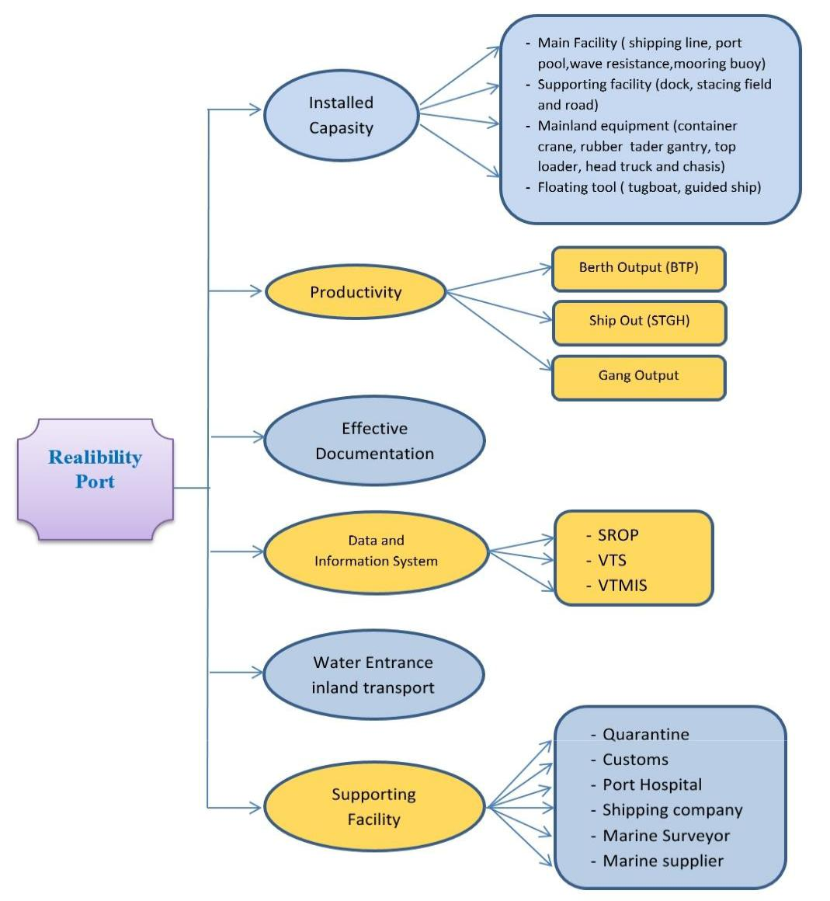

**Figure 1.** Framework

Table 1.1. List of Bitung Port Mooring Facilities

|  |  |  |  |
| --- | --- | --- | --- |
| **No.** | **Wharf** | **Length**  **(m)** | **Deep**  **(MLWS)** |
| 1 | Samudera Wharf | | |
|  | a. Samudera I | 190 | 9 |
|  | b. Samudera II | 243 | 10 |
|  | c. Samudera III | 175 | 10 |
| 2 | IKD Wharf | 146 | 7 |
| 3 | Nusantara Wharf | | |
|  | a. Nusantara I | 251 | 6 |
|  | b. Nusantara II | 148 | 5 |
|  | c. Nusantara III | 207 | 6 |
| 4 | Local Wharf | 60 | 6 |
| 5 | LCT Wharf | 20 | 7 |
| 6 | Container Terminal Wharf | 358 | 11 |

From the table, it could be seen that the depth of the berth mooring facility in Bitung port on MLWS was located at the Container Terminal Wharf. It was 11 m which allowed the fully

cellular generation vessel with a carrying capacity of up to 2500 TEUs, while the lowest depth was 5 m at Nusantara 2 jetty which allowed Pelni passenger ships with drafts of up to 3.5 m and feeders to lean there.

a. Floating Tool

Table 1.2. List of Bitung Port Floating Tools

|  |  |  |
| --- | --- | --- |
| **No** | **Vessel Name** | **Capacity** |
| 1 | Pilot Boat | 3 unit |
|  | a. MPS Siladen | (2X130 HP-6 KNOT) |
|  | b. MPI Sarena | (2X300 HP-8 KNOT) |
|  | c. MPC Arprang | (2X350 HP-25 KNOT ) |
| 2 | Tug Boat | 2 unit |
|  | a. TB Bunaken | (2X750 PS) |
|  | b. TB Todano | (2X1000 HP) |

Floating equipment facilities at Bitung Port included 3 Pandu Ships with speeds ranging from 6 to 25 knots. For other facilities, it consisted of two tugs with a power of 750 and 1000 HP which use eachtwo engines. By the assumption that the length of the delay service for 1 ship taking 15-30 minutes, the existing facilities was possible to serve more than 48 ships that are required to delay overnight.

b. Cargo Service Facilities

Table 1.3. List of Cargo Service Facilities at Bitung Port

|  |  |  |  |
| --- | --- | --- | --- |
| **No** | **Facility** | **Amount** | |
| 1 | Wharf |  | |
|  | 1. Samudera Wharf | 6.955 | M2 |
|  | b. IKD Wharf | 2.920 | M2 |
|  | c. Nusantara Wharf | 8.130 | M2 |
|  | d. LCT Wharf | 200 | M2 |
|  | e. Local Wharf | 600 | M2 |
| 2 | Warehouse |  | |
|  | a. Warehouse A | 4.320 | M2 |
|  | b. Warehouse D | 4.320 | M2 |
|  | c. Butler Warehouse | 432 | M2 |
| 3 | Stacking Yard | 43.414 | M2 |
| 4 | Electricity (PLN) | 555 | KVA |
| 5 | Generator | 500 | KVA |
| 6 | Water (PDAM) | MAX.200 | T/J |
| 7 | Bunker | MAX.150 | T/J |

Cargo service facilities included five wharf consist of Samudera Wharf, IKD Wharf, Nusantara Wharf, LCT Wharf and Local Wharf with a total of 18,805 m², three warehouses consist of Warehouse A, Warehouse B and Butler Warehouse with a total area of 9,072 m², a stacking area of 43,414 m², electricity with PLN sources with a capacity of 555 kVA supported by the availability of 500 kVA capacity generator, freshwater filling facilities with maximum pump speed 200 tons / hour and bunker facilities with a maximum rate of 150 tons/ hour.

c. Loading and unloading equipment facilities

For loading and unloading services, the facilities owned by the Port of Bitung included 1 reach stacker with a carrying capacity of 45 tons, 1 land crane with a capacity of 25 tons, three forklifts with capacities of 2.3 and 5 tons respectively,two pieces with a capacity of 7 tons , 3 truck heads with a capacity of 30 tons each, 2 tronton pieces with a capacity of 18 tons each, 2 chassis 20 feet, 3 chassis 40 feet and 1 fire truck ready to extinguish the fire around the port area with transport capacity of 5 tons as shown at Table 1.4. below:

Table 1.4. List of Bitung Port Loading and Unloading Equipment Service Facilities

|  |  |  |
| --- | --- | --- |
| **Facilities** | **Amount** | **Capacity** |
| Reachstaker | 1 | 45 Ton |
| Shore Crane / Container Crane | 1 | 25 Ton |
| Forklift | 1 | 2 Ton |
| Forklift | 1 | 3 Ton |
| Forklift | 1 | 5 Ton |
| Forklift | 2 | 7 Ton |
| Head Truck | 3 | 30 Ton |
| Tronton | 2 | 18 Ton |
| Chasis | 2 | 20 Feet |
| Chasis | 3 | 40 Feet |
| Fire trucks | 2 | 5 Ton |

d. Passenger and Visitor Service Facilities

For the convenience of passengers at Nusantara Wharf, Bitung Port prepared a two-storey passenger terminal with a total capacity of 1,780 people with 1040 seats in a room with a total area of 2544 m2. Each floor was equipped with AC, TV, Toilet and Wi-Fi networks easily accessed. For parking, a land area of 2,100 m2 had been prepared for 4-wheeled vehicles and 294 m2 for 2-wheeled vehicles as showed below:

Table 1.5. List of Passenger and Visitor Service Facilities in Bitung Port

|  |  |  |
| --- | --- | --- |
| **No** | **Facilities** | **Capacity** |
| 1 | Passenger Terminal 1st Floor | 1.272 m2 |
|  | a. Person | 1.060 org |
|  | b. Seat | 720 seats |
|  | c. AC, TV, Toilet, Wi-fi | available |
| 2 | Passenger Terminal 1st Floor | 1.272 m2 |
|  | a. Person | 1.060 org |
|  | b. Seat | 320 seats |
|  | c. AC, TV, Toilet, Wi-fi | available |
| 3 | Parking Area for 4-wheeled vehicles | 2.100 m2 |
| 4 | Parking Area for 2-wheeled vehicles | 294 m2 |

e. Security Facilities

In terms of security facilities, Bitung Port as an international hub had fully implemented the International Ship and Port Facility Security Code (ISPS Code) which required CCTV, metal detectors, access card systems and mirror detectors at each port entry access. In addition, it is also equipped with a safety fence, radio communication, AIS live, Fire Fleet and Rescue also collaborates with a port security unit consisting of KPPP, KPLP and Navy from Lantamal VIII in the Bitung area as showed at Table 1.6. below:

Table 1.6. List of Bitung Port Security Facilities

|  |  |  |
| --- | --- | --- |
| **No** | **Facility** | **Location** |
| 1 | CCTV | Passanger Terminal |
|  |  | Gate/Pos 4 (entry gate) |
|  |  | Gate/Pos 1 (exit gate) |
|  |  | Stacking Yard |
| 2 | Metal Detector | Entry Gate |
| 3 | Access Card System | Entry Gate |
| 4 | Mirror Detector | Entry Gate |
| 5 | Security Border/Railing | All area |
| 6 | Radio Communication | Navigation Control Station |
| 7 | AIS Live | Navigation Control Station |
| 8 | Fire Rescue | Bitung Port Area |
| 9 | Security Board |  |
|  | KPPP (Harbour Police) | Bitung Port Area |
|  | KPLP (Coast Guard) | Bitung Port Area |
|  | Angkatan Laut (Navy) | Bitung Port Area |

**2**. **Port Productivity**

a. Berth Output (BTP)

Findings about Berth Output showed a significant trend of decreasing the number of cargoes and BTP values in 2012 to 2013 and continuing to decline until 2016. Throughout the year the assessment from 2012-2016 had no addition long Wharf but BTP values continued to decline. This was a problem for the port of Bitung in supporting the Sea Toll program, so that attention was given to maintain the continuity of the flow of cargoes in the Port of Bitung so that the function of the sea toll could occur as showed below:

Table 2.1. List of Berth Output (BTP) of Bitung Port in the last 5 years

|  |  |  |
| --- | --- | --- |
| Year | Cargo Amount  (Ton) | BTP  (Ton/M) |
| 2012 | 4.310.163 | 723,00 |
| 2013 | 4.246.946 | 121,621 |
| 2014 | 3.454.859 | 73,37 |
| 2015 | 2.635.892 | 66,11 |
| 2016 | 1.827.676 | 59,30 |

b. Ship Output

The findings of Ship Output on Bitung Port showed the trend of increasing the number of cargoes and STP values on ships with Foreign line ship in 2013 and 2016 compared to STP on Domestic Line Ship shipping. This showed that the Port of Bitung functioned as an international hub port.

The value of Ship Output on 2012 until 2016 as showed at Table 2.2. below:

Table 2.2 List of Ship Output (STP) of Bitung Port in the last 5 years

|  |  |  |
| --- | --- | --- |
| Year | *STP*  *(ton per ship per hour in port = T/K/J)* | |
| Foreign Line Ship | Domestic Line Ship |
| 2012 | 110,00 | 100,00 |
| 2013 | 818,94 | 285,86 |
| 2014 | 773,01 | 273,39 |
| 2015 | 714,31 | 243,79 |
| 2016 | 1.025,61 | 238,43 |

c. Gang Output

Productivity Standards of Port for Ton/Gang/Hour in accordance with the Decree of the Director General of Sea Transportation UM.002/38/18/DJPL-11 concerning Port Operational Performance Standards for Bitung port is 20 Ton/ Gang/Hour.

The results of the 2012-2016 achievements for the Output Gang at Bitung port showed good standard for both Foreign Line Service and Domestic Line Service, except for achievements in conventional terminals that were far below the minimum required as showed below:

Table 2.3. List of Gang Output of Bitung Port in the last 5 years (T/G/J or B/G/J)

|  |  |  |  |  |  |
| --- | --- | --- | --- | --- | --- |
| **Type of Ship or Line Service** | **Gang Output** **(Ton/Gang/hour OR Box/Gang/hour)** | | | | |
| **2012** | **2013** | **2014** | **2015** | **2016** |
| 1. Foreign Line Service (Export-Import) | | | | | |
| 1. General Cargo  Ship (T/G/H) | 22,00 | 22,64 | 22,31 | 22,65 | 22,63 |
| 2.Other Cargo  (T/G/H) | 23,00 | 23,29 | 22,27 | 22,35 | 22,32 |
| B. Domestic Line Service | | | | | |
| 1. General Cargo Ship (T/G/H) | 21,00 | 22,26 | 22,21 | 22,09 | 22,06 |
| 2. Other Cargo  (T/G/H) | 20,00 | 22,28 | 22,75 | 22,48 | 22,76 |
| C. Container Ship  (B/C/H) |  |  |  |  |  |
| 1. Container Terminal | 22,00 | 24,00 | 24,00 | 24,00 | 24,00 |
| 1. Conventional Terminal | 12,00 | 12,00 | 12,00 | 12,00 | 12,00 |

3. Effective Documentation

Recognition and certification of ISO 9001 edition in 2015 was real evidence that the Port of Bitung represented by PT. Pelindo IV Bitung Branch as a Port Business Entity that functions as a port operator had a strong commitment in guaranteeing its service quality standards. By the guarantee of quality standards, effective documentation in port operations would be fulfilled. Pillars in service quality assurance included service quality policies, service quality procedures, documentation and records of all service activities carried out. Documentation effectiveness at Bitung Port was also supported by effective documentation in the Inaportnet System which was a breakthrough in data management and port information systems that strongly support the existing Sea Toll program.

4. Data and Information Systems

To ensure the reliability of a port, the existence of data and information systems for the benefit of shipping safety and for flow of cargoes was a demand that must be fulfilled. The launch of the Inaportnet system on August 8, 2017 for Bitung Port was a breakthrough and a guarantee of reliability in supporting the National Logistics System (SISLOGNAS).

It was globally competitive and was a concept of the Sea Toll Road.Inaportnet was an open and neutral electronic portal to facilitate the exchange of data and information on port services in a fast, safe, neutral and easy way that was integrated with relevant government agencies, port business entities and logistics industry players who utilize port services such as shipping lines/agents, freight forwarders, CFS (Container Freight Station), Custom brokerage/PPJK, importers & exporters, depot containers, warehouses, and inland transportation (trucks, trains and barges) so that port operations are easier, more efficient and effective.

The benefits of this Inaportnet system include a) Single submission; b) Online services, save time and costs; c) Acceleration of the whole process; d) Tracing and tracking capabilities; e) Minimize data and document entry errors; f) Receive electronic data integration; g) Can monitor the process; and h) Increasing the competitiveness of industry players.

In terms of shipping safety guarantees, the existence of the Coast Radio Station (SROP) and Vessel Traffic System (VTS) carried out by the Bitung Class I Navigation District which included 15 SROP and 1 VTS providing services in the form of fixed schedule news broadcasts and news, news broadcasts relay in the form of forwarding news from other stations or forwarding news from ship information deemed important for other vessels in the Bitung VTS working area and information for certain vessels, which according to Bitung VTS assessment are in a situation that could endanger certain vessels or other vessels.

5. Water Entrance dan Inland Transportation

The existence of the water entrance at Bitung Port had existed and had grown together with the existence of the Bitung Port itself. The access of water to the port of Bitung was very possible from all hinterland areas and collecting ports around it. From the shore side, access to the Bitung port was connected to the Trans Sulawesi national road, while the railway transportation mode was currently under construction until 2019 where the route to Bitung was a development priority scale. The development of the Port of Bitung was also supported by the development of the industry in the city of Bitung which consists of PT. Salim Ivomas Pratama (Bimoli Cooking Oil), PT. Semen Tonasa, PT. Delta Facific Indotuna (Canning Tuna), PT. Agro Makmur Raya and PT. Multi-Vegetable Sulawesi.

6. Existence of Supporting Facilities

Various activities in the port were in the form of loading and unloading activities and raising passengers, completing administrative documents, refueling, repairs, providing supplies, drinking water and smooth service for passengers and the contents of the customs, immigration, quarantine, and customs offices. Port security and representatives or branch offices of shipping and Stevedoring companies are available and ready to support the operational activities of Bitung Port. So did hospitals, it had been registered as hospitals that have received approval from the Director General of Sea Transportation for seafarers' health services including the issuance of Seaman Medical Certificate connected on line with the Indonesian sailor data base system ([www.pelaut.go.id](http://www.pelaut.go.id)).

**4. CONCLUTION**

The six reliability elements that are assessed at Bitung Port have generally fulfilling in supporting the Sea Toll program, except for the Port Productivity element from the aspects of Berth Output (BTP) and Output Gang which experience decreasing trend amount of loading from year to year in the BTP calculation and not achieved of standard Gang Output required for the transport of Containers at Coventional Port. To maximize the reliability element of Bitung Port in supporting the Sea Toll Program launched by the government, it is recommended that a local government study of the flow of cargoes passing through Bitung Port be carried out. Is it caused by a decrease in community purchasing power or a decrease in hinterland resources in Bitung Port BTP values from year to year decreasing. Furthermore, from the port operator, it is possible to evaluate the causes of the low of Gang Output value of container loading in Conventional Wharf whether caused by lack of cargoes flow or due to lack of skills of loading and unloading workers employed or due to inadequate capacity of loading and unloading equipment at the Conventional Wharf.

**REFERENCES**

Saut, Gurning, R. O., Hariyadi, B., E., *Management of Port Bussiness*, Jakarta: APE Publishing, 2007.

Triatmodjo, Bambang, *Planning of Port*, Yogyakarta: Beta Offset, 2009.

Jinca, M. Y., *Indonesia Sea Transportation, The Analysis System and Case Study*, Jakarta: Brilian Internasional, 2011.

Mailisan, Johny, *The Effect of Ships and Cargoes Service to the Loading and Unloading Productivity at Port of Sunda Kelapa*, Jakarta: Development and Research Center on Sea Transportation, Ministry of Transportation, 2014.