http://ejournal.stipjakarta.ac.id

|  |  |
| --- | --- |
|  | *METEOR STIP MARUNDA* |
| pISSN : 1979 – 4746  eISSN : 2685 - 4775 | ***Maritime Institute of Jakarta*** |

|  |
| --- |
| **Analysis of Container Shifting During Voyage Using the Fishbone Method on KM. Tanto Senang**    1David Maulana Salsabilla Kusuma, 1Anugrah Nur Prasetyo, 1Dyah Ratnaningsih, 1Anak Agung Ade D P Y  *1Maritime Polytechnic of Surabaya, Surabaya, Indonesia*  *email :* [*maulanadavid941@gmail.com*](mailto:maulanadavid941@gmail.com) |
| *submitted : ______________ revised : ____________ accepted : ___________* |

***Abstract***

*Container shifting during sea voyages is a critical issue that poses serious risks to the safety of ships, cargo, and crew, as well as causing potential financial and operational losses. This study aims to analyze the primary causes of container shifting on KM. Tanto Senang and provide preventive recommendations. A descriptive qualitative method was used, with the Fishbone diagram approach to identify root causes. Data were collected through observations, interviews, documentation, and secondary data from the vessel’s operational reports. The findings indicate that container shifting is mainly caused by an insufficient number of lashing gears, inadequate cargo watch supervision, and unsafe loading methods. The study recommends routine inspections of lashing gear, improved lighting in the working environment, and the implementation of safe loading procedures in accordance with maritime operational standards.*

**Keywords**: *Cargo Shifting, Cargo Watch, Fishbone diagram, Lashing Gear, Maritime Safety.*

*Copyright © 2018,* ***METEOR STIP MARUNDA***, *ISSN:1979-4746, eISSN :2685-4775*

|  |
| --- |
| ***Keywords****:* *Cargo Shifting, Cargo Watch, Fishbone diagram, Lashing Gear, Maritime Safety.* |

# INTRODUCTION

The use of containers has revolutionized logistics and freight transportation systems, enabling high efficiency in the shipment of large volumes of goods [1]. Maritime transportation has become the backbone of global logistics distribution, particularly in Indonesia, where, as an archipelagic nation, sea freight plays a crucial role. One of the most efficient and widely adopted methods today is the container system. The use of containers in public transportation is expected to continue growing, while the shipping industry is anticipated to undergo significant advancements in container protection technologies, allowing cargo to be delivered to ports more efficiently in terms of both cost and time [2]. This system is designed to simplify loading and unloading processes, accelerate delivery times, and enhance the security of transported goods.

In the shipping industry, the use of containers as cargo transport media has become a vital component in supporting the smooth operation of global logistics. In the field of maritime transportation, particularly in the transport of goods or cargo, there have been changes and improvements with the introduction of containers, which have established a new system [3]. While this facilitates the rapid global movement of containers and contributes to cost efficiency, it simultaneously exacerbates the maneuverability challenges associated with operating large-scale vessels [4]. Cargo units, including containers, shall be loaded, stowed and secured in accordance with official guidelines approved by maritime authorities. [5], [6]. All cargo must be properly stowed and adequately secured to ensure the safety of both the vessel and all individuals on board [7]. One of the crucial aspects of container transportation aboard vessels is stability and safety, which heavily rely on securing methods, commonly referred to as lashing. The lashing system is designed to prevent containers from shifting during voyages, especially due to wave impacts, strong winds, and inevitable ship manaeuver during transit. With the increasing volume of containers being loaded, every vessel is required to be equipped with adequate lashing equipment to ensure that each container is securely fastened and remains in position throughout the voyage. Proper cargo securing not only aims to prevent damage to goods but also ensures that containers arrive at their destination ports safely, on time, and with cost-effective shipping [8], [9].

Uncontrolled shifting of containers on board can result in various negative consequences, including cargo damage, workplace accidents, and significant economic losses. Therefore, understanding proper lashing techniques and the risks that may cause container movement is crucial in the shipping industry to ensure the optimal safety of the vessel, cargo, and crew also such damage compromises the structural integrity of the container, affects cargo safety, and increases operational costs [10], [11].

However, despite the many advantages offered by the container system in freight transport, field practices show that container shifting during voyages remains a recurring issue. The World Shipping Council reports that, on average, more than 3,000 containers are lost at sea each year, indicating that container movement and securing practices remain serious concerns in the global logistics chain [12]. This situation not only results in cargo damage but also poses high risks to the safety of the vessel and its crew, as well as significant financial losses for shipping companies.

The responsibilities of shipboard personnel during port stays are critical to safeguarding cargo, the vessel, and the surrounding environment, particularly during loading and unloading activities. All personnel assigned to watchkeeping duties, whether at sea or in port, are obligated to perform their responsibilities in accordance with the safety principles. These duties encompass the supervision of cargo operations, maintenance of vessel security, and the establishment of effective communication between the ship and shore authorities [13]. Effective cargo watch and port watchkeeping are fundamental components of safe and efficient maritime operations. These duties not only ensure the integrity of cargo handling processes but also contribute significantly to the overall safety and coordination between ship and shore personnel. Watchkeeping duties at port extend beyond navigation and include supervision while the vessel is berthed. Effective scheduling of port watchkeeping duties by the master is essential to ensure the safety of life, the vessel, the port facility, and the environment, particularly during cargo handling operations [14]. Cargo watch plays a critical role in ensuring safety and security during cargo handling operations. It involves monitoring the condition of cargo and cargo handling equipment, as well as maintaining effective communication between the vessel and port authorities. This role is essential in preventing cargo damage, occupational accidents, and ensuring overall operational efficiency [15].

Based on the review of these conditions, container shifting during sea voyages remains a critical issue that requires greater attention from technical, supervisory, and operational management perspectives. A similar case was experienced by KM. Tanto Senang, in which container shifting occurred during a voyage, indicating unresolved operational, procedural, and human error factors. Therefore, a comprehensive analysis is necessary to identify the root causes in order to develop effective solutions.

In this study, the Fishbone diagram method is used as a tool to analyze the root causes of container shifting aboard the KM. Tanto Senang vessel. This method enables researchers to map various contributing factors—ranging from materials, work methods, supervision, to human elements—which can then serve as the basis for formulating recommendations to improve cargo handling safety and security. The primary objective of this research is to identify the contributing factors to container shifting aboard KM. Tanto Senang and to provide practical recommendations to minimize similar risks in future shipping operations, both for this vessel and the national maritime industry in general.

# METHOD

This study employs a qualitative research method, which is an exploratory process that enables the researcher to gain an in-depth understanding of the subject's world [16]. The method is used to deeply comprehend a phenomenon through data collection in a natural setting. This research focuses on the meanings participants assign to their experiences, thereby producing results that are descriptive and holistic in nature [17]. Qualitative research is an approach used to explore and understand the meanings that individuals or groups attribute to social or human problems, and it is conducted through narrative data collection, interviews, observations, and document analysis [18]. qualitative research allows flexible investigation, enabling researchers to adjust methods as needed to deeply explore the subject's world.

The Fishbone Diagram, also known as the Cause and Effect Diagram, was originally developed by Dr. Kaoru Ishikawa. It serves as a systematic tool for identifying, analyzing, and illustrating potential root causes of a specific problem, typically associated with quality deficiencies or operational defects [19]. The Fishbone diagram is used to identify the root causes of workplace accidents by grouping contributing factors into categories such as human, method, machine, material, and environment, it has become a key diagnostic tool for analyzing and illustrating problems through root cause analysis [20].

This approach is well-suited for exploring perspectives within specific contexts. Common techniques include in-depth interviews, participatory observation, and document analysis. Researchers interact directly with participants to gain nuanced insight into situations or processes being studied. Qualitative research is characterized by its flexibility, contextual focus, and holistic approach—making it ideal for identifying patterns, meanings, and understanding social phenomena in a natural setting.

The research was conducted on board KM. Tanto Senang, operated by PT. Tanto Intim Line, with supporting observations made during loading and unloading operations at Port of Manokwari. The data was obtained from field notes, relevant theses, operational events, crew interviews, and direct researcher observations.

The research took place during a 12-month on-board internship from July 2023 to July 2024. The study utilized both primary and secondary data

For the primary data acquired through direct observation of lashing gear use, cargo watch practices, and incidents of container shifting during operations. Additional insights were obtained through interviews with ship crew members who directly experienced or observed these events.

For the secondary data sourced from operational documentation, academic references, and credible online sources to support and strengthen the primary findings.

**Data Following Techniques**

The following data collection methods were used are interviews. Structured and semi-structured interviews were conducted with key informants, including the Master, Chief Officer, Third Officer, and other crew members. These interviews aimed to explore the causes and impacts of container shifting and strategies to mitigate future occurrences. A guided interview protocol was developed to ensure consistency and relevance in questions.

The next data collection method is observation. Systematic field observations were carried out to examine real-time cargo handling conditions, including the use and sufficiency of lashing gear, supervision (cargo watch), and the overall safety of loading/unloading activities. Observational instruments included checklist tables tailored to research objectives, focusing on condition and availability of lashing equipment, cargo handling procedures, Supervision effectiveness, environmental and safety conditions.

For the last data collection is documentation. Relevant documents such as operational logs, container loading records, and accident reports were analyzed to complement primary data. This technique also included photographic documentation and technical inspection records.

# RESULTS AND DISCUSSION

**Results**

In this study, the researcher conducted direct observations, interviews with key informants such as the Master, Chief Officer, and Third Officer, as well as documentation during the research conducted aboard the KM. Tanto Senang vessel. The data collected revealed that container shifting during the voyage was caused by several interrelated primary factors.

Based on interviews with the Master, one of the main causes of container shifting was the insufficient ratio of lashing gear to the number of containers, particularly stacking cones, which are essential locking devices for each container tier onboard. A significant number of stacking cones were inadvertently taken ashore due to negligence by stevedores and crew members. Furthermore, the absence of routine inspections on the availability and condition of lashing gear contributed to the failure to secure containers adequately during the voyage.

In addition, supervision during cargo handling (cargo watch) was found to be suboptimal. This was attributed to the limited number of crew members responsible for monitoring and the high number of port workers involved, especially during the loading of containers onto the second and third tiers. These conditions led to lapses in oversight, resulting in container shifts going undetected.

The Chief Officer also emphasized that the cargo handling method used at the Port of Manokwari did not conform to safe operational procedures. Containers were loaded using multiple hooks on a single crane, allowing several containers to be lifted simultaneously. While this method sped up the loading process, it significantly increased the risk of container collisions—particularly on upper tiers—which ultimately led to containers shifting from their intended positions.

Findings from interviews with the Third Officer further indicated that fatigue experienced by crane operators and dock workers was a critical factor contributing to errors during cargo operations. This was influenced by prolonged working hours that exceeded safe limits, especially during night shifts aimed at meeting departure schedules. Such fatigue heightened the risk of operational mistakes, including unintentional container contact and shifting.

In addition to human factors, the work environment also contributed to the level of risk. Poor lighting conditions during night time cargo operations hampered effective supervision and cargo securing efforts by both crew and dock workers. This situation increased the potential for human error, directly impacting cargo and crew safety.

Observation activities were carried out aboard the KM. Tanto Senang from April 2024, starting when the vessel was docked before its voyage to Manokwari, and continued until the completion of cargo operations in May 2024. The objective of the observation was to identify the causes of container shifting, evaluate the condition of the lashing gear, and understand the obstacles encountered during cargo handling operations.

During voyage preparation, the pre-trip lashing inspection revealed a significant shortage of lashing equipment, particularly stacking cones, compared to data recorded in inspections conducted two months earlier. This shortage was attributed to equipment damage and limited resupply capabilities aboard the vessel.

Table. 1 Difference of Lashing Gear

|  |  |  |  |
| --- | --- | --- | --- |
| **Lashing Gear Type** | **March 2024** | **May 2024** | **Difference** |
| Lashing Rod 2 Tier | 91 | 83 | 8 |
| Lashing Rod 3 Tier | 66 | 60 | 6 |
| Twistlock | 312 | 300 | 12 |
| Stacking Cone | 261 | 159 | 102 |
| Double Stacking Cone | 120 | 106 | 14 |
| Bridge Fitting | 65 | 58 | 7 |
| Turnbuckle | 163 | 158 | 5 |
| Extension Piece | 18 | 13 | 5 |

During the cargo handling process at the Port of Manokwari, containers were loaded using portal cranes equipped with a double hook system. While this method expedited the loading process, it often led to collisions between containers due to the difficulty faced by operators in controlling the load when lifting more than one container simultaneously. Out of 44 containers measuring 40 TEUs that were loaded, 12 containers were found to have shifted, and 2 containers shifted without detection until after the vessel had departed.

Furthermore, the dock workers involved in the loading process did not fully understand the correct procedure for installing stacking cones, requiring the ship’s crew to personally verify the placement on top of the containers. This situation was exacerbated by a work schedule that extended late into the night, resulting in fatigue among both dock workers and crane operators. The combination of fatigue and miscommunication between the ship’s crew, dock workers, and crane operators emerged as a key factor contributing to improper container placement and inadequate securing during loading.

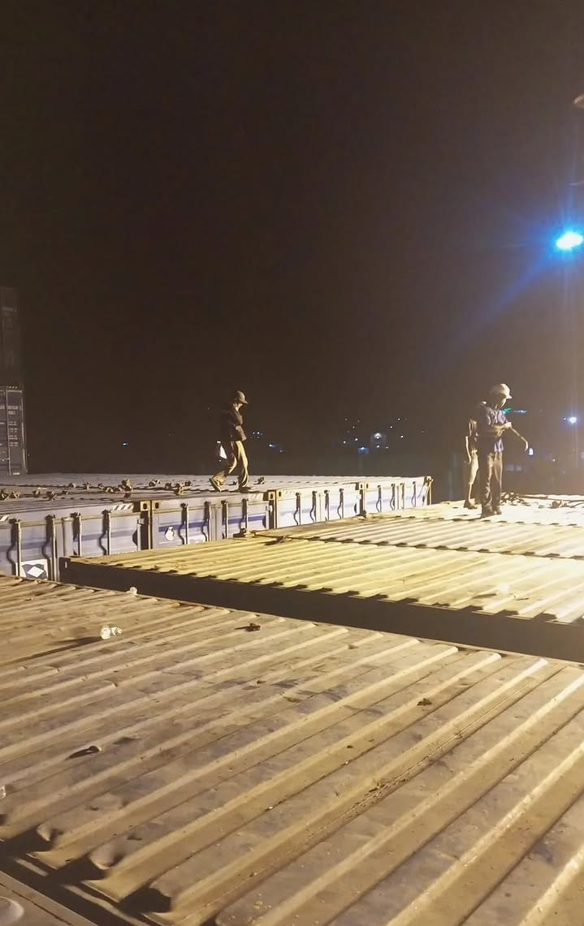

Figure 1. Installation of stacking cones on top of container by dock workers

**Discussion**

Based on the results of observations, interviews, and documentation, the researcher conducted an analysis using the Fishbone Diagram method (also known as the Ishikawa diagram). The analysis revealed that the causes of container shifting can be categorized into several main factors:

1. Material Factor

This relates to the inadequate availability of lashing gear in proportion to the number of containers, as well as the presence of damaged or unfit lashing equipment.

1. Human Factor

This includes fatigue among dock workers and crane operators, a lack of understanding of safe loading procedures, and insufficient supervision due to the limited number of crew members.

1. Machine Factor

Refers to the limitations of port loading equipment, such as the use of portal cranes, which tend to be unstable when lifting more than one container at a time.

1. Method Factor

Involves container loading procedures that deviate from established safety standards, such as the use of multiple hooks in a single lift operation, which may speed up the process but compromise safety.

1. Environmental Factor

Pertains to poor lighting conditions in the work area during night time operations, which hampers effective supervision and increases the risk of operational errors during container loading.

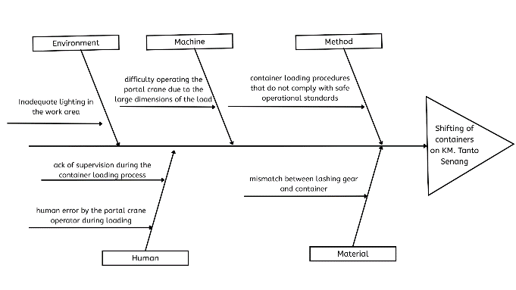

Figure 2. Diagram Fishbone

Based on the results of the analysis, it is concluded that container shifting aboard KM. Tanto Senang is caused by a combination of factors, including inadequate safety equipment, weak supervision during cargo handling, non-compliance with safe operational procedures, unfavorable working conditions, and fatigue experienced by dock workers and crane operators.

Therefore, efforts to minimize the risk of container shifting must be carried out comprehensively. These efforts include the provision of adequate lashing gear, routine inspections, increased supervisory personnel, improvement of loading methods in accordance with standard procedures, and enhancement of the working environment, particularly in terms of adequate lighting in cargo handling areas.

# CONCLUSION

Based on the research findings regarding container shifting aboard the KM. Tanto Senang, it can be concluded that the issue is caused by a combination of interrelated factors, including technical, procedural, and human elements. The primary factor identified is the inadequate ratio of lashing gear—particularly stacking cones—to the number of containers loaded, stemming from a lack of regular inspections and insufficient supervision during loading and unloading operations.

Additionally, ineffective supervision during the cargo watch process, due to a limited number of personnel, further increases the likelihood of container shifting. The use of unsafe loading methods, such as lifting multiple containers simultaneously with several hooks to accelerate loading operations, is another significant contributing factor. This condition is exacerbated by an unsupportive working environment, particularly poor lighting in cargo handling areas at night, which elevates the risk of human error.

Moreover, fatigue experienced by dock workers and crane operators, due to extended working hours and pressure to complete cargo operations within a tight timeframe, also contributes to container securing errors.

To minimize the risk of container shifting, comprehensive corrective measures are necessary. Recommended actions include conducting routine inspections of lashing gear, increasing the number of personnel assigned to cargo watch, implementing container loading methods that adhere to standard safety procedures, and improving the quality of the working environment, including enhanced lighting in cargo handling areas.

In addition, managing the working hours of laborers and crane operators is crucial to reduce fatigue-related safety risks. By implementing these measures, it is expected that cargo safety during voyages can be significantly improved and the risk of container shifting minimized effectively.

# REFERENCES

1. A. Pramono, A. Kusharyanto, Y. S. Devianti, A. Premadi, and N. A. Winarno, “Kajian peranan depo petikemas guna mereduksi penumpukan petikemas di PT Jakarta International Container Terminal Pelabuhan Tanjung Priok,” E-Journal Marine Inside, vol. 1, no. 1, pp. 48–71, 2019. [Online]. Available: <https://doi.org/10.56943/ejmi.v1i1.7>
2. A. Asbullah, D. Ginting, and Suparman, “Analisis keterlambatan dan efisiensi kegiatan bongkar muat petikemas di Terminal PT. Prima Terminal Petikemas Belawan,” *Innovative: Journal of Social Science Research*, vol. 4, no. 1, pp. 10156–10166, 2024.
3. E. Hinriyani, "Analisis Keterlambatan dan Efektivitas Kinerja Bongkar Muat Petikemas di Pelabuhan Tanjung Priok," *Jurnal Manajemen Transportasi dan Logistik,* vol. 3, no. 2, pp. 45–58, 2020. ​
4. N. Goicoechea and L. M. Abadie, “Optimal Slow Steaming Speed for Container Ships under the EU Emission Trading System,” Energies, vol. 14, no. 22, p. 7487, 2021, doi: [10.3390/en14227487](https://doi.org/10.3390/en14227487).
5. International Maritime Organization, *Revised Guidelines for the Preparation of the Cargo Securing Manual (MSC.1/Circ.1353/Rev.2),* 2022. [Online]. Available: <https://imorules.com/GUID-40038DDE-B0D2-4036-883E-DDBE9BA04352.html>
6. The Standard Club, *Cargo Stowage and Securing: A Guide to Good Practice*, 2nd ed. London, UK: Witherby Publishing Group, 2019.
7. J. M. Pérez-Canosa and J. A. Orosa, "A New Methodology for Optimization of Lashing Lines in the Securing Arrangement of Non-Standardized Cargo on Ships," *Applied Sciences*, vol. 14, no. 23, p. 11442, 2024. [Online]. Available: https://doi.org/10.3390/app142311442
8. D. Tyczynski, "Impact Detection Methodology for Monitoring Container Damage During Handling Operations," *Sensors (Basel)*, vol. 24, no. 2, p. 1872, Jan. 2024. doi: 10.3390/s240201872
9. Aziz, S., & Andromeda, V. F. Teknik pelashingan muatan *container* on deck pada kapal MV. Oriental Ruby untuk penanggulangan bergesernya muatan. *Jurnal Dinamika Bahari*, 10(1), 2445–2450, 2019
10. The Standard Club, Best Practice Guidelines for Stowage and Securing of Steel Cargoes, London, UK: Witherby Publishing Group, 2019.
11. United Nations Conference on Trade and Development. (2023). Review of Maritime Transport 2023: Towards a Green and Just Transition. United Nations. <https://unctad.org/publication/review-maritime-transport-2023>
12. World Shipping Council. (2024). Containers Lost at Sea: 2024 Update. World Shipping Council. <https://www.worldshipping.org/safety>
13. International Maritime Organization (IMO), *STCW Convention and STCW Code: Including 2010 Manila Amendments*, 2017 ed. London, UK: IMO Publishing, 2017. ISBN: 978-92-801-1635-9. [Online]. Available: https://doi.org/10.62454/KD938E
14. Kuncowati, "Pentingnya Pengaturan Dinas Jaga Pelabuhan dan Beban Kerja Awak Kapal terhadap Kinerja Awak Kapal pada Saat Dinas Jaga di Pelabuhan Surabaya," *Jurnal Sains dan Teknologi Maritim*, vol. 4, no. 2, pp. 45–53, 2020.
15. D. J. House, *Cargo Work: For Maritime Operations*, 9th ed. Abingdon, UK: Routledge, 2024.
16. Hardani *et al.*, *Metode Penelitian Kualitatif & Kuantitatif*, Yogyakarta: Pustaka Ilmu, 2020.
17. U. Ridlo, *Metode Penelitian Studi Kasus: Teori dan Praktik*, Jakarta: CV Jejak, 2022.
18. A. Cordell and I. Thompson, *The Fishbone (Ishikawa) Diagram*, in *The Quality Improvement Handbook*, 1st ed., London: Routledge, 2018, pp. 57–68. [Online]. Available: <https://doi.org/10.4324/9781351239509-8>
19. D. C. R. Silva, D. M. Belderrain, and F. A. P. Costa, “Cause and Effect (Fishbone) Diagram: A Tool for Analyzing and Diagnosing Healthcare Processes,” *Journal for Healthcare Quality*, vol. 7, no. 2, pp. 85–91, Mar. 2019. [Online]. Available: <https://doi.org/10.1097/JHQ.0000000000000224>
20. J. W. Creswell and J. D. Creswell, *Research Design: Qualitative, Quantitative, and Mixed Method Approaches*, 5th ed. Melbourne: SAGE Publications, 2018.