http://ejournal.stipjakarta.ac.id

|  |  |
| --- | --- |
|  | *METEOR STIP MARUNDA* |
| pISSN : 1979 – 4746  eISSN : 2685 - 4775 | ***Maritime Institute of Jakarta*** |

|  |
| --- |
| **Identification of Load Management System on KM Bung Tomo**  **as Passanger Ship R-16**  *1Arleiny,1Moejiono Moe,1 Damoyanto Purba,1Mutiara Paulina Latuheru,1 Renta Novaliana Siahaan*  *1* *Maritime Polytechnic of Surabaya, Surabaya, Indonesia*  *email:* [*arleiny@poltekpel-sby.ac.id*](mailto:arleiny@poltekpel-sby.ac.id) |
| Submitted on : 20/10/2024 Revised : 15/11/2024 Accepted : 20/12/2024 |

# *Abstract*

*Cargo handling systems on pioneer passenger ships are generally designed for efficiency and safety in loading and unloading goods and other cargoes. The following are some of the components that are generally found in the cargo handling system on pioneer passenger ships: among others include Cargo Storage Area, Cargo Handling Equipment, Fastening and Buffer Systems, Labeling and Tracking Systems, Information and Management Systems, Safety and Training Procedures, Routine Maintenance, Overall Cargo Regulation, cargo handling systems on pioneer passenger ships must be designed and operated with regard to efficiency, security, and compliance with applicable maritime regulations. This research was carried out on KM Tomo which implements Route R 16 with 9 ports. This research uses a qualitative method using observation, interview and documentation methods. Primary data is obtained directly by observing and interviewing the Skipper and secondary data is obtained from data collection and documentation..*

|  |
| --- |
| *Copyright ©2024,* ***METEOR STIP MARUNDA***, *pISSN: 1979-4746, eISSN: 2685-4775* |
| ***Keywords:*** *cargo handling, pioneer ship, load management* |

# INTRODUCTION

Pioneer shipping plays an important role in ensuring access to transportation, reducing price disparities, and expanding the mobility of people and goods in areas of need. With the increased allocation of pioneer transport subsidies in 2023, the Ministry of Transportation is committed to humanizing people by providing more extensive and equitable sea transport services. Pioneer shipping uses several types of vessels that play an important role in connecting remote, frontier, underdeveloped, and border (3TP) areas with larger ports.

This research aims to identify the main issues that arise in the cargo handling system on KM Bung Tomo as a pioneering ship. The focus of this study is to uncover operational, technical, and managerial challenges that can affect efficiency and safety in the loading and unloading process on this vessel. Through the identification of these issues, it is expected to gain a deeper understanding of the factors that slow down processes, increase the risk of accidents, or hinder the distribution of goods to remote areas.

This research is expected to provide a clearer perspective on areas that need improvement. The results of this study will serve as a foundation for future recommendations, allowing for enhancements in the cargo handling system on KM Bung Tomo to improve operational efficiency and safety. Here are some types of ships used in pioneer shipping:

1. Pioneer Ship: This ship connects small ship transportation with large ships. Pioneer vessels can carry up to 500 people and operate in areas that are not served by land or air transportation. Island communities rely heavily on pioneer ships to ensure access to transportation and a smooth economy on remote islands.

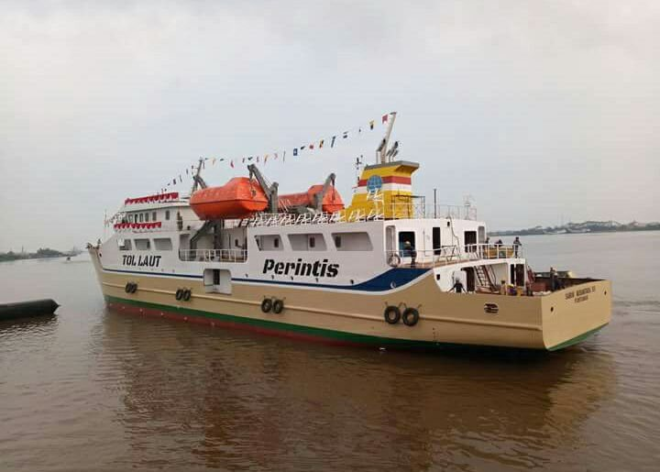

Figure 1. KM Sabuk Nusantara 61 Ship

1. Fast Boats: Some pioneer shipping routes are served by fast boats, such as MV Express Priscillia 88 which connects Gorontalo with Pagimana. Fast ships have high speed and speed up connectivity between regions.

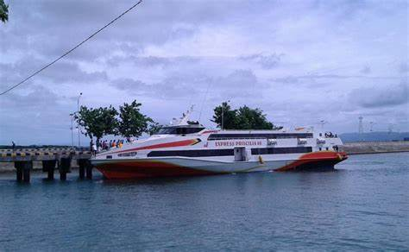

Figure 2. MV Express Priscillia 88

1. Pilotage Mother Ship: These vessels are also used in pioneering voyages. For **example**, there are three units of pilotage motherships stationed in Makassar, Sorong, and Bitung. The mother ship has a length of about 60 meters and a speed of about 12 knots.

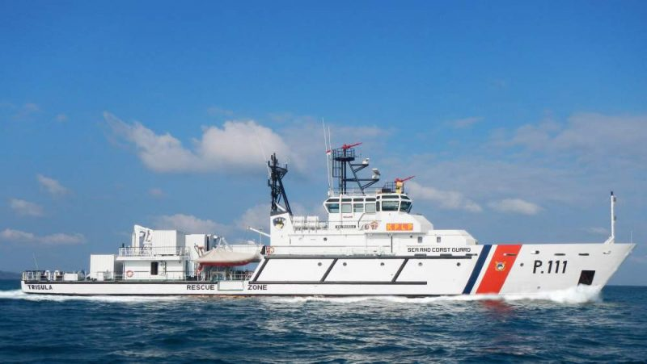

Figure 3. The Mother Ship of Browsing, namely KN Kalian

Source: Kemenhub Luncurkan Kapal Induk Perambuan Dukung Tugas Kenavigasian: Okezone Nasional

The transformation of training ships into pioneer ships is a strategic step to expand connectivity and ensure mobility in remote, frontier, underdeveloped, and border areas (3TP) throughout the Unitary State of the Republic of Indonesia (NKRI). Here is some information about the change of training ships to pioneer ships:

1. Reduced Operational Intensity: The sailing intensity of a number of pioneer ships throughout Indonesia has been reduced. This reduction was made due to minimal cargo occupancy. As a result of this policy, the mobility of people in the outer islands is limited, and they have to wait for the arrival of the ship for up to one month.
2. New Scheme: The Directorate of Sea Transportation of the Ministry of Transportation has issued a letter addressed to PT Pelni as one of the pioneer shipping operators. The letter contains the socialization of the pioneer ship operation scheme. This policy of reducing operational intensity has been carried out since June 28, 2022. Transportation Minister Budi Karya Sumadi explained that the evaluation was carried out considering the low occupancy. The scheme implemented is to extend the shipping operational period, so that pioneer ships that used to operate once a week now operate 10 days or every two weeks, the goal is to increase occupancy.

Figure 4. Development of Pioneer Crossing Transportation in the Last Five Years

BPSDM Training Ship: In addition, there are seven BPSDM Transportation training vessels that will be operated as state-owned pioneer vessels. These vessels are in seaworthy condition and will replace cargo ships as the main vessels in pioneer shipping. Thus, by 2024, there will be no more pioneer sea transportation routes served using freight ships.

# METHOD

Based on the opinion of Walidin & Tabrani (2015, p. 77) qualitative research is a research process to understand human or social phenomena by creating a comprehensive and complex picture that can be presented in words, reporting detailed views obtained from informant sources, and conducted in a natural setting. Qualitative research has a descriptive nature and tends to use an inductive approach analysis, so that the process and meaning based on the subject's perspective are more highlighted in this qualitative research (Fadil, 2020, p. 33). According to Sugiyono (2019, p. 18) qualitative research methods are research methods based on the philosophy of postpositivism which are used to examine objects with natural conditions (real conditions, not set or in experimental conditions) where the researcher is the key instrument.

This research employs a qualitative approach to gain an in-depth understanding of the cargo handling system on KM Bung Tomo. This approach is chosen because it allows for the exploration of experiences, perspectives, and challenges faced by stakeholders in the field.

The method is optional for original research articles. This method is written in descriptive and should provide a statement regarding the methodology of the research. This method as much as possible to give an idea to the reader through the methods used. This Method are optional, only for original research articles.

This study will involve 10-15 respondents, consisting of:

1. Crew Members: 5-8 individuals, including the captain, officer, and crew members directly involved in the loading and unloading process.
2. Port Officials: 3-5 individuals who can provide insights into the infrastructure and procedures at the ports.
3. Operational Managers: 1-2 individuals responsible for managing ship operations and coordinating with port authorities.

# RESULTS AND DISCUSSION

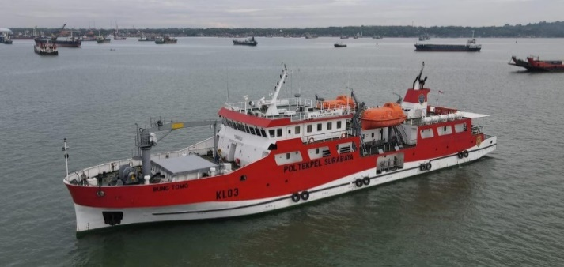

Figure 5. KM Bung Tomo

This research was taken from the Bung Tomo Training Ship which has now turned into a Pioneer Ship or KM Bung Tomo Passenger Ship, starting from the beginning of 2023 where the letter of change begins with the addition of Information on the Gross Deed of the Ship. And there are many changes from all sectors, especially related to routine ship financing, which includes crew salaries, food, supplies and others.

Ship Operating Time includes ship sailing time and ship berthing time at the port. Ship sailing time is the time the ship travels while at sea, which is calculated from the port of origin to the port of destination.

Table 1. List of Port Names and Mileage KM Bung Tomo R-16 Ship

|  |  |  |  |  |  |  |  |
| --- | --- | --- | --- | --- | --- | --- | --- |
| **No** | **Nama Pelabuhan** | **Jarak (NM)** | | **Waktu Tempuh (Hours)** | | | |
| **Speed**  **6** | **Speed**  **7** | **Speed**  **8** | **Speed**  **9** |
| 1 | Kalianget - Masalembo | 113 | | 18,83 | 16,14 | 14,13 | 12,56 |
| 2 | Masalembo - Keramaian | 40 | | 6,67 | 5,71 | 5,00 | 4,44 |
| 3 | Keramaian - Matasiri | 72 | | 12,00 | 10,29 | 9,00 | 8,00 |
| 4 | Matasiri - Maradapan | 20 | | 3,33 | 2,86 | 2,50 | 2,22 |
| 5 | Maradapan - Marabatuan | 22 | | 3,67 | 3,14 | 2,75 | 2,44 |
| 6 | Marabatuan - Pelaihari | 53 | | 8,83 | 7,57 | 6,63 | 5,89 |
| 7 | Pelaihari - Batulicin | 77 | | 12,83 | 11,00 | 9,63 | 8,56 |
| 8 | Batulicin - Kotabaru | 22 | | 3,67 | 3,14 | 2,75 | 2,44 |
| 9 | Kotabaru - Batulicin | 22 | | 3,67 | 3,14 | 2,75 | 2,44 |
| 10 | Batulicin - Pelaihari | 72 | | 12,00 | 10,29 | 9,00 | 8,00 |
| 11 | Pelaihari - Marabatuan | 53 | | 8,83 | 7,57 | 6,63 | 5,89 |
| 12 | Marabatuan - Maradapan | 22 | | 3,67 | 3,14 | 2,75 | 2,44 |
| 13 | Maradapan - Matasiri | 20 | | 3,33 | 2,86 | 2,50 | 2,22 |
| 14 | Matasiri - Keramaian | 72 | | 12,00 | 10,29 | 9,00 | 8,00 |
| 15 | Keramaian - Masalembo | 40 | | 6,67 | 5,71 | 5,00 | 4,44 |
| 16 | Masalembo - Kalianget | 113 | | 18,83 | 16,14 | 14,13 | 12,56 |
| **Total** | | | **833** | **138,83** | **119,00** | **104,13** | **92,56** |

In the table it can be seen that the KM Bung Tomo ship has 9 ports of call namely Kalianget, Masalembo, Keramaian, Matasiri, Maradapan, Marabatuan, Batulicin, Kotabaru, with an overall distance of 833 NM, with various types of cargo, and passengers.

1. Number of Passengers and Goods

The amount of passenger and freight demand on pioneer vessels tends to fluctuate and is highly dependent on geographical, economic, social, and policy factors. In areas that rely heavily on pioneer ships as the main mode of transportation, demand is usually stable and high, especially for logistical goods and basic necessities The number of passengers and goods on pioneer ships has increased in recent years. This increase shows the important role of pioneer ships in connecting remote, underdeveloped, and outermost areas, and in supporting passenger mobility and goods distribution in these areas.

Table 2. Data on the number of passengers and goods KM Bung Tomo R-16

|  |  |  |  |  |  |
| --- | --- | --- | --- | --- | --- |
| **No** | **Tanggal** | **Jumlah Barang** | **Jumlah Penumpang** | **Laporan**  **Bulanan** | **Jumlah Total** |
| 1 | 20 maret - 04 April | 3 | 103 | **Maret** | **103** |
| 2 | 04 April - 18 April | 6 | 278 | **April** | **556** |
| 3 | 18 April - 3 Mei | 8 | 278 |
| 4 | 04 Mei - 18 Mei | 2 | 96 | **Mei** | **303** |
| 5 | 19 mei - 31 Mei | 8 | 207 |
| 6 | 01 Juni - 12 Juni | 35 | 144 | **Juni** | **631** |
| 7 | 13 Juni - 23 Juni | 0 | 0 |
| 8 | 24 Juni - 05 Juli | 33 | 487 |
| 9 | 06 Juni - 08 Juli | 0 | 0 |
| 10 | 09 Juli - 22 Juli | 83 | 562 | **Juli** | **946** |
| 11 | 23 Juli - 01 Agust | 45 | 384 |
| 12 | 02 Agust - 12 Agust | 84 | 610 | **Agust** | **720** |
| 13 | 13 Agust - 25 Agust | 34 | 110 |

In the table it can be seen that during Eid the number of passengers immediately increases, while the existence of the KM Bung Tomo ship is still newly operated as a pioneer ship, this attracts public interest in traveling by sea transportation.

Figure 6. Graph of the number of passengers and goods KM Bung Tomo

In the table and graph, it can be seen that the use of KM Bung Tomo as an R-16 Pioneer Ship is needed on the East Java route.

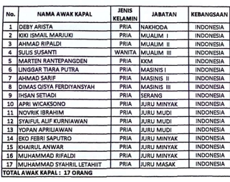

Figure 7. Crewlist of KM Bung Tomo

Table 4. 3 List of KM Bung Tomo R-16 Ship Tariff





Source: KM Bung Tomo Documentation

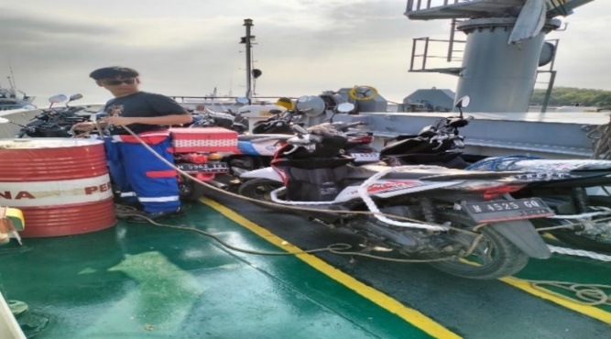

Figure 8. Two-wheeled vehicle load on the ship's deck

Ship also carries a cargo of two-wheeled vehicles belonging to passengers, properly checked by the bosun, Here are the general steps that need to be followed:

1. Document Preparation: Make sure you have all the necessary documents, such as crossing tickets, STNK, and KTP.
2. Fuel Tank Capacity: The vehicle's fuel tank should be filled to no more than half its capacity. This is to reduce the risk of fire or explosion during the trip.
3. Vehicle Inspection: Before boarding the ship, your vehicle will be inspected by officers to ensure there are no dangerous or illegal items.
4. Queuing and Placement: Follow the officer's directions to queue and place the vehicle in the designated area inside the ship. Usually, motorcycles are placed in a special area that is safe and easily accessible.
5. Vehicle Security: Once the vehicle is placed, make sure to lock the handlebar and use the center standard. Some boats provide additional safety straps to ensure the vehicle does not move during the trip.
6. Following Ship Rules: Obey all rules and instructions from the ship's crew during the trip. This includes not being in the vehicle area while the ship is sailing unless authorized.
7. Vehicle Retrieval: Once the ship arrives at its destination, follow the officer's directions to retrieve your vehicle in a safe and orderly manner.

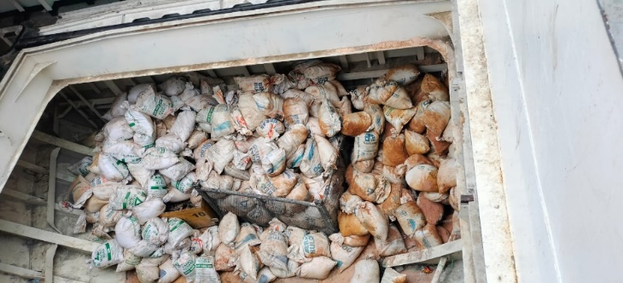

Figure 9. Sand loading using sacks positioned in the hold

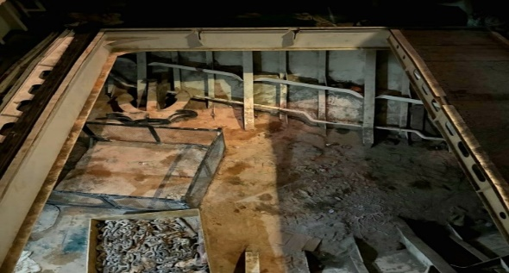

Figure 10. Hatch condition when the sand cargo has been unloaded

In the previous picture it can be seen that for the handling of free cargo using sacks, once in the hold or cargo hold, there is damage to the sacks and sand will be scattered in the hold. Analysis of existing data, the author gained an understanding of the importance of cargo identification before the ship loads at the ports visited, especially due to limited communication and signals at some ports so that the cargo manifest that must be proposed before the ship arrives is not carried out. The obstacle that often arises is when different types of cargo, such as loading basic necessities such as rice, food ingredients, and entering cargo such as building materials so that there will be broken and mixed cargo. In motorized vehicles, there is also a concern that if the weather conditions are not good, it can cause the vehicle to move because it is tied up not in accordance with existing regulations.

# CONCLUSION

The conclusion of the research on the identification of cargo on the R 16 pioneer ship can include several important points that are usually related to the type and characteristics of the cargo carried, the capacity of the ship, and the factors that affect the distribution of cargo. Some of the things related to this conclusion are:

1. Research conclusions about identifying cargo handling procedures on KM Bung Tomo as a pioneer ship -16.

Research on cargo handling procedures on the KM Bung Tomo as an R-16 pioneer ship aims to identify the processes and steps involved in loading and unloading activities and how efficiency and safety can be improved by:

a) Variation of Load Types

The research identified that the pioneer vessel R-16 transports various types of cargo, both for passenger and logistics needs. Common types of cargo identified include:

1) Basic necessities such as rice, oil, and sugar.

2) Fuel such as gasoline and diesel.

3) Building goods and equipment such as cement, iron, and construction tools.

4) Agricultural commodities or natural products originating from remote areas, marine products.

b) Factors Affecting Load Identification

The research also identified several factors that influence the type and amount of cargo carried by the R 16 pioneer ship, including:

1) The maximum load limit for passengers and goods must be adhered to in order to maintain the stability and safety of the ship during the voyage.

2) Increased demand for food cargo during the holiday season or when approaching the holidays.

3) Weather and sea conditions: Bad weather or extreme sea conditions may limit the carrying capacity of the vessel, especially for heavier or vulnerable goods.

2. Can routes that require pioneer vessels be handled, after the BPSDM Training Vessels?

1) Availability of infrastructure at ports: Small ports in remote areas often have limited infrastructure to handle loading and unloading of goods efficiently.

2) Local needs: Each region served by pioneer ships has different needs, so the identification of cargo must take into account the characteristics of the region and the needs of the local population.

3) The use of modern technology such as cargo tracking systems, port management information systems, and digital communication helps in optimizing time and minimizing errors.

The closing divided into two parts, they are conclusion and suggestion. The conclution can be in the form of finding generalization based on the research problems. Suggestions can be in the form of input/proposition for future researchers.

## Suggestions

Research suggestions related to load identification on R 16 pioneer ships can be focused on various aspects that aim to improve the efficiency, safety, and reliability of ship operations. Here are some suggestions that can be considered for further development. The following suggestions are aimed at improving efficiency and safety in the identification and management of cargo on the pioneer ship R 16. Further research in various aspects, namely:

1. Development of a digital system for load management to avoid overloading or uneven load distribution by providing accurate data on the weight and placement of goods on board.

2. Optimization of cargo capacity management division of cargo space based on type of cargo and priority (e.g. essential goods vs. commercial goods) to make it more efficient

3. Research on cargo demand patterns in remote areas analyzing the seasonal needs of specific goods such as food, fuel, or certain commodities

4. Research on the impact of weather on cargo management by planning alternative routes or modifying voyage schedules to avoid dangerous sea conditions for vessels with heavy loads

5. Crew training in cargo management

6. Comparative study with other vessels

## Acknowledgments

Thank you to those who have helped in this research, especially the Director of the Politeknik Pelayaran Surabaya, Mr. Moejiono who strongly supports all lecturers in developing the potential of lecturers in research as Affiliates, and also to the POLTEKTRANS SDPas the host of the IWPOSPA International Conference Inland Water and Ferries Transpor research seminar.

**REFERENCES**

1. Ayuningtyas, A. R., "Model Evaluasi Efektivitas Dan Efisiensi Layanan Kapal Perintis: Studi Kasus Wilayah Papua Barat," *04411540000008-Undergraduate_Thesis.pdf*, its.ac.id, .
2. Priadi, A. A., Laju, I. K., Nur, H. I., Achmadi, T., & Verdifauzi, A., "Evaluasi Penyelenggaraan Angkutan Kapal Perintis di Indonesia Tahun 2015-2020," *Warta Penelitian Perhubungan*, dephub.go.id, .
3. Ariany, Z., Hendra, A., & Febriary, S., "Standart Pelayanan Minimal (SPM) Dan Sistem Lasing Pada Kapal Ro-Ro Untuk Keselamatan Transportasi Penyeberangan Laut," *Gema Teknologi*, 2018.
4. Arikunto, S., *Prosedur Penelitian Suatu Pendekatan Praktik*. Jakarta: Rineka Cipta, 2014.
5. Choirul, A., & Fonsula, V., "Penanganan Muatan Peti Kemas Guna Menunjang Keselamatan Muatan Kapal Selama Berlayar Studi Kasus Di MV.Sinar Sumba," *Majalah Ilmiah Gema Maritim*, vol. 22, no. 1, 2020.
6. Jalaluddin, H., & Idi, A., *Filsafat pendidikan : manusia, filsafat, dan pendidikan*. Jakarta: Rajawali Pers, 1942.
7. Hanafi, A. A., & Indriyati, R., "Pelayanan Keberangkatan dan Kedatangan Kapal Penumpang Pada PT. ASDP Indonesia Ferry (Persero) Cabang Bakkauheni," *Politeknik Bumi Akpelni*, 2021.
8. Karana, S., *Penanganan Kendaraan Bermotor Pada Kapal Angkutan Penyeberangan*. Jakarta: Pusat Tekologi Industri Dan Sistem Transportasi BPPT, 2010.
9. Kementerian Perhubungan Republik Indonesia, Direktorat Jenderal Perhubungan Laut., "Keputusan Direktur Jenderal Perhubungan Laut Nomor KP-DJPL 729 Tahun 2023, tentang Penerapan Jaringan Trayek Penyelenggaraan Publik Untuk Angkutan Laut Perintis Tahun Anggaran 2024," 2023.
10. Kismantoro, T., *Penanganan dan Pengaturan Muatan*. Semarang: PIP Semarang, 2020.
11. "Konektivitas Pelayaran Perintis Sebagai Bagian Sistem Distribusi Logistik Dalam Mendukung Keberhasilan Tol Laut," *ResearchGate*, 2023. . Available: <https://www.researchgate.net/publication/354318562>.
12. Martopo, A., & Soegiyanto., *Penanganan Muatan*. Semarang: Politeknik Ilmu Pelayaran Semarang, 2004.
13. Fitrah, M., & Luthfiyah., *Metodologi penelitian : penelitian kualitatif, tindakan kelas & studi kasus*. Yogyakarta: Pustaka Pelajar, 2016.
14. Kata Omed., "Rute Lengkap Dan Jadwal Kapal Perintis KM Sabuk Nusantara di Indonesia," *Kata Omed*, .
15. Sarosa, S., *Analisis Data Penelitian Kualitatif*. Sleman: PT. Kanisius, 2021.
16. Soewedo, H., *Penanganan Muatan Kapal (Cargo Handling) di Pelabuhan & Peralatannya*. Jakarta: Buku Maritim Djangkar, 2015.
17. Sudjatmiko, F., *Pokok-Pokok Pelayaran Niaga*. Jakarta: Toko Gunung Agung, 2007.
18. Sutarman, A., *Pengantar Teknologi Informasi*. Jakarta: PT. Bumi Aksara, 2012.
19. Syam, M., & Sunusi, S., "Implikasi Pengawasan Muatan," 2023.
20. Utami, T., & Dewi, A. M., "Peningkatan Pelayanan Muatan Kendaraan Pada Kapal KM. Mutiara Timur 1," *Majalah Ilmiah Gema Maritim*, 2020.
21. Wahyuni, E., Silvia, M., & Saidah, D., "Produktivitas Bongkar Muat Kapal Ro-Ro PT ASDP Indonesia Ferry," *Jurnal Manajemen Bisnis Transportasi Dan Logistik*, 2017.
22. Winartha, I., *Metodologi Penelitian Kuantitatif dan Kualitatif*. Yogyakarta: Gaha Ilmu, 2006.
23. "Metode Penelitian Deskriptif Kualitatif (Konsep & Contoh)," *serupa.id*, .
24. "Pengertian Identifikasi, Proses dan 4 Contohnya," *dosensosiologi.com*.