http://ejournal.stipjakarta.ac.id

|  |  |
| --- | --- |
|  | *METEOR STIP MARUNDA* |
| pISSN : 1979 – 4746  eISSN : 2685 - 4775 | ***Maritime Institute of Jakarta*** |

|  |
| --- |
| **Transportation Efficiency Based on Empowerment of Private and Government Businesses With The Concept of Collaboration**  *1 Romanda Annas Amrullah, 1 Faris Nofandi,1 Agus Dwi Santoso,1 Arleiny,*  *1 Saipul Imam Subakti, 1 Rizki Adi Pratama*  *1 Maritime Polytechnic of Surabaya, Surabaya, Indonesia*  *email:* [romanda.annas@poltekpel-sby.ac.id](mailto:romanda.annas@poltekpel-sby.ac.id) |
| Submitted on : 07/10/2024 Revised : 11/11/2024 Accepted : 20/12/2024 |

# *Abstract*

*The disproportionate growth between the transportation fleet and the infrastructure causes congestion, pollution, inconvenience and poor service. However, the high growth in transportation fleets managed by the private sector more than those managed by the government is not effective, on the other hand the government does not have enough funds to provide adequate public transportation facilities, so the concept of Allocation Cheap Sourcing is needed which is a collaboration between fleets managed by the private sector and the government. The method used in this study is Evidence based policy . The results of the study show that the effectiveness of collaboration can be in the form of partnerships and new forms of organization (NFO).*

|  |
| --- |
| *Copyright ©2024,* ***METEOR STIP MARUNDA***, *pISSN: 1979-4746, eISSN: 2685-4775* |
| ***Keywords:*** *allocation cheap sourcing, government, policy, private, transportation fleet* |

# INTRODUCTION

The competitive advantage proposed by Poter's is a strategy that emphasizes two things, first cost leadership and second product differentiation [1] Cost leadership is put forward Focus on minimize costs, cheap sources and modern technology [2] . Facts show that logistics costs in Indonesia are more expensive than ASEAN countries, Indonesia is 23.2% while ASEAN is 4% - 5%. This is due to the absence of goods being transported back at the time of transportation to the starting point. Changing means of transportation, there is no one goal yet. The Indonesian Chamber of Commerce (KADIN) emphasized that there must be an alternative to the problem of expensive logistics transportation [3]

Cost Leadership Strategy, explores how organizations can effectively leverage these frameworks to optimize costs, improve operational efficiency, and secure a dominant position in the market [4]. Study [5] concluded that cost leadership strategies have a very strong, positive and significant relationship with sustainability measures. This is done through an assessment of the Cost Leadership and Differentiation strategy in relation to planning, accumulation and use of resources, and the formation of core competencies (or internal dynamics).

Cost leadership facilitates the sustainability of business operations. Unprecedented changes in business operations such as supply, demand, and transportation performance. Transportation systems and operations must adapt to accommodate and facilitate these changes [6]. The transportation sector plays a crucial role in improving access to opportunities and influencing individual economic and social outcomes. It also contributes to sustainable development around the world and is an important global actor in the 2030 Agenda for Sustainable Development [7]. Vehicle allocation is the main challenge for sustainable transportation. The Vehicle Allocation Problem (VAP) consists of repositioning empty vehicles in a set of terminals at a specific planning period to maximize the profits generated from serving the demand for freight transportation between a pair of terminals [8]. Some of the problems faced in logistics at Indonesia among others, infrastructure transportation which is inadequate in some areas, complicated bureaucracy in the process of shipping goods and services, as well as technological limitations in data and information processing. The problems of transportation management and business in Indonesia are high costs, lack of transportation equipment provided by the government, poor infrastructure and lack of coordination between institutions. Based on these problems, Cheap resource allocation (Allocation Cheap Sourcing) is a very urgent need. This research is important because it determines the sustainability of the transportation business managed by the private sector and the smooth running of public transportation and the efficiency of the government in the field of transportation management.

# METHOD

The method used in this study is Evidence based policy . The time required for policy research is relatively short and addresses public attention at any given moment. The data collected in the research can be in the form of primary and secondary data. The data used in policy analysis is in the form of numbers or words (narratives or descriptions of a condition). The results of the data analysis will be able to assist policy analysts in making conclusions about a problem and in providing recommendations to solve policy problems.

# RESULTS AND DISCUSSION

PELNI operates 26 passenger ships which serves 1,058 sections and stops at 71 ports. Meanwhile, in 2022, the number of ships carrying out activities in Indonesian waters reached 10.534, and as many as 9,458 of them are foreign ships. Based on a report by the Ministry of Transportation (Kemenhub), the number of ocean fleets in Indonesia is as many as 72.313 units in 2021 [9]. For land transportation owned by the government, Perum Damri has a total fleet of 2,000 units, with 200 units being electric buses while the total bus fleet in Indonesia is as much as 30,780 units, 420 aircraft but Garuda Indonesia group only has 202 Aircraft Fleet [10].

Data shows that the comparison between transportation fleets managed by the Government and the private sector is much more owned and managed by the private sector. The large number of fleets has an impact on congestion, is ineffective and causes air pollution [11]. Congestion [12] Socioeconomic losses and fuel waste [13]. Results [14] to reduce congestion and air pollution by means of an optimal speed of 31km/h. However, this will cause delays in the community reaching the goal. Restrictions on vehicle fleets are almost impossible to do because they are related to freedom of business by the private sector and will interfere with investment Affects low-income households [15].

Transportation operated by the private sector has suffered losses both on routes within the city and outside the city. Bantul intra-provincial intercity transportation routes (AKDP) and rural transportation (Angkudes) are starting to be empty of passengers. Public bus companies have suffered extraordinary losses, many bus fleets are not operating due to the absence of passengers [16] Almost the same condition is also experienced by the government-managed fleet. Batu City Terminal is Empty of Passengers, Angkot Reduces 50 Units, DAMRI Closes [17]. The reason passengers do not want to use public transportation, both managed by the government and SWSTA, is because: longer travel time, congestion and juggling, uncontrolled schedule, limited operating time and more expensive [18].

Collaboration between transportation fleets managed by the government and the private sector is important. Collaboration has a transformative effect with a relatively lower initial productivity rate and a maintenance effect with a relatively higher initial productivity [19]. Collaboration, it's about how we work together, and the tools we use to do it [20]. The benefits of collaboration to reduce work overload and prioritization will be even more challenging [21] A collaborative workplace is created when one encourages broad alignment of strategic objectives and the other encourages local community-led interactivity to operationalize those goals [22]

The unbalanced and uneven number of fleets throughout Indonesia requires co-abortion, with the aim of equitable distribution of public services [23] . Collaboration model in partnership [24] Contingency [25]. New forms of organizing (NFO) such as communities are increasingly relevant as new collaboration partners for organizations [26]. A partnership molaboration model or a new form of organization may be the right one because collaboration between the government and the private sector has been difficult to do until now.

Table 1. Collaboration Model

|  |  |  |
| --- | --- | --- |
| **Remarks** | **Partnership** | **NFO** |
| Fleet status | Privately owned | Shared ownership |
| Labor status | Private | SOEs |
| Vehicle maintenance | Privately insured | Jointly covered |
| Management | Determined by the government | Combined |
| Liability for fleet accident risk | Privately insured | Jointly covered |
| Routing | Government | Government |
| Revenue sharing | 70 % swsta, 30 % government | 30% private, 30% government, 40% maintenance |

Partnership collaboration model or The new form of organization (NFO) in terms of determining routes is in the government, the goal is to equalize transportation services throughout Indonesia. The route that applies in this collaboration still applies to the route determination model that is currently underway, but if there is an area that urgently needs a transportation fleet, the status of tuslah (urgent) can be used. The collaboration model used is the Allocation Cheap Sourcing system, which allocates resources (vehicles, fleets, tools) that are available, abundant and easy to drop to areas that are still lacking or in need. The concept of Allocation Cheap Sourcing (figure 1) is a collaboration of theories Competitive Advantage with Business Operation [27]

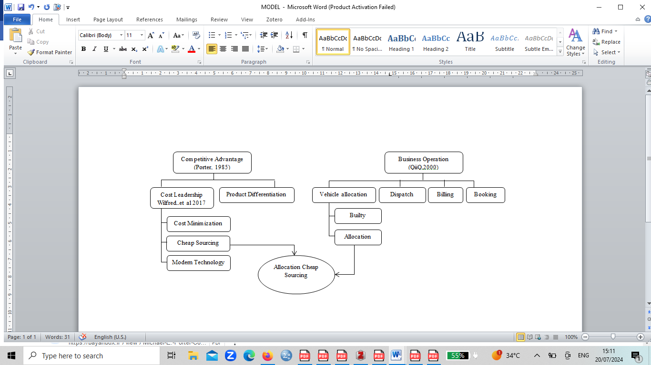

*Fig. 1. Concept of the Allocation Cheap Sourcing model*

The working pattern of the Allocation Cheap Sourcing system is a shuttle. Vehicles, fleets or means of transportation from the starting point carry goods/people to the destination and return by carrying goods/people without having to wait, the difference with what is already running today is that the vehicle, fleet or means of transportation at the time of return is never empty because the goods or people have been prepared in advance by the partnership or NFO. The operational process of the Allocation Cheap Sourcing system in figure 2



*Fig. 2. Operational process of the Allocation Cheap Sourcing system*

Table 2. Advantages of the Allocation Cheap Sourcing system

|  |  |  |
| --- | --- | --- |
|  | Private | Government |
| Fleet status | Full operational | No need to buy |
| Labor status | Work around the clock | Can win power |
| Vehicle maintenance | Lightweight as there is certainty for maintenance costs | Privately insured |
| Management | It's easier because there are already passengers/consumers | Lighter assisted by the private sector |
| Liability for fleet accident risk | The risk of accidents can be minimized because of good management | Jointly covered |
| Routing | Government | Government |
| Revenue sharing | Profit sharing is certain | The government can invest in other things, the distribution is according to the risk, there are not too many vehicles |

# CONCLUSION

After The growth of vehicles from year to year is getting higher and not accompanied by infrastructure construction will cause high levels of congestion, pollution and no comfort. On the other hand, the number of fleets that are not proportional between those managed by the private sector and the government causes many problems that arise. The fleet that is large by the private sector is not optimally used because of poor service and the government fleet that is slightly less able to serve the entire community who want to use public transportation. So, the System Allocation Cheap Sourcing is the right time to use it with collaboration between fleets managed by the private sector and the government. Models that can be used with partnership patterns or with new forms of organization (NFO) models. The purpose of collaboration between the private sector and the government is to equitably distribute public transportation services that are comfortable, safe and reduce congestion levels.

## Acknowledgment

We would like to express our gratitude to all reviewers who have contributed to the peer review process. The support and professional assistance from all esteemed reviewers have made this journal worthy of publication.

**REFERENCES**

[1] E. Tchouamou Njoya and H.-M. Niemeier, “Do dedicated low-cost passenger terminals create competitive advantages for airports?,” *Cancer Lett. - CANCER LETT*, vol. 1, pp. 55–61, Aug. 2011, doi: 10.1016/j.rtbm.2011.06.005.

[2] W. N. Marangu, E. Mwiti, and E. Thoronjo, “Analysis of Cost Leadership Strategy Influence on Organizations’ Competitiveness of Sugar Firms in Kenya,” *Eur. J. Bus. Manag.*, vol. 9, pp. 38–49, 2017, [Online]. Available: https://api.semanticscholar.org/CorpusID:55063815

[3] R. . Handoyo, “Sea cargo costs are expensive, Kadin encourages export routes by air,” *VOA ID*, 2021.

[4] D. A. Jerab and T. Mabrouk, “Achieving Competitive Advantage through Cost Leadership Strategy: Strategies for Sustainable Success,” *SSRN Electron. J.*, pp. 1–17, 2023, doi: 10.2139/ssrn.4574945.

[5] M. Bhat, A. Agrawal, and M. V. Barmpas, “Differentiation, Cost Leadership, or Ending Up in the Middle? A Reflection on the Viability of Porter’s Generic Strategies through a Case Study Comparison of McDonalds and Starbucks,” *Athens J. Bus. Econ.*, vol. 10, no. 3, pp. 217–238, 2024, doi: 10.30958/ajbe.10-3-3.

[6] Bureau of Transportation Statistics: US Department of Transportation, “Transportation Statistics Annual Report,” *Transp. Stat. Annu. Rep.*, no. 1–222, p. 226, 2010, [Online]. Available: https://books.google.com/books?id=Xohu_3ooPhEC&pgis=1

[7] *ITF Transport Outlook 2023*. in ITF Transport Outlook. OECD, 2023. doi: 10.1787/b6cc9ad5-en.

[8] European Commission, “Proposal for a Regulation on circularity requirements for vehicle design and on management of end-of-life vehicles,” no. December, 2023, [Online]. Available: https://commission.europa.eu/strategy-and-policy/priorities-2019-2024/european-green-deal/industry-

[9] M. A. Riski, “Kapal Laut di Indonesia Pada 2021,” *Dataindonesia.id*, 2022. https://dataindonesia.id/otomotif-transportasi/detail/ada-72313-kapal-laut-di-indonesia-pada-2021

[10] Fery, “ini-jumlah-armada-angkutan-mudik-2024-untuk-layani-1936-juta-pemudik,” *Republika*, 2024.

[11] P. Dutta, “THE ENVIRONMENTAL IMPACTS OF VEHICLE POLLUTION,” Mar. 2023.

[12] A. D. Amelia, M. I. Arib, Y. S. Renaldi, T. S. Hartono, and S. V. Ramos, “The Effect of Traffic Jam on High Levels of Student Stress,” *Apl. J. Res. Trends Soc. Sci. Humanit.*, vol. 2, no. 1, pp. 46–50, Jun. 2023, doi: 10.59110/aplikatif.v2i1.123.

[13] S. Helmi and W. Wahab, “Traffic Congestion Effect on Socio-Economic of Road Users in Palembang City,” 2023, pp. 80–90. doi: 10.2991/978-2-38476-072-5_9.

[14] P. N. Benedikter, “How to Reduce Congestion I : The Optimal Speed Limit for Urban Traffic,” pp. 1–7, 2024.

[15] *Investment barriers in the European Union 2023: a report by the European Investment Bank Group*. European Investment Bank, 2024. doi: 10.2867/45894.

[16] A. Haryanto, “Armada Nganggur di Garasi, Perusahaan Bus di Cimahi Terancam Bangkrut,” *Sindonews*, 2021.

[17] K. Amrullah, “Terminal Kota Batu yang Sepi Penumpang,Angkot Berkurang 50 Unit, DAMRI Tutup,” *Jawapos*, 2023.

[18] A. Fadli, “Lima Alasan Orang Membenci Transportasi Umum,” *Kompas*, 2022.

[19] A. Johnston and D. Prokop, “University Engagement and Productivity in Innovative SMEs: An Empirical Assessment,” *ERC Work. Pap. No. 78*, no. September, p. available at https://www.enterpriseresearch.ac.uk/, 2019.

[20] M. Benerdal and A.-K. Westman, “Organising for collaboration with schools: experiences from six Swedish universities,” *Scand. J. Educ. Res.*, pp. 1–13, Oct. 2023, doi: 10.1080/00313831.2023.2263476.

[21] A. Gupta and C. Gupta, “A novel collaborative requirement prioritization approach to handle priority vagueness and inter-relationships,” *J. King Saud Univ. - Comput. Inf. Sci.*, vol. 34, no. 5, pp. 2288–2297, May 2022, doi: 10.1016/j.jksuci.2019.12.002.

[22] B. A. Barker Scott and M. R. Manning, “Designing the Collaborative Organization: A Framework for how Collaborative Work, Relationships, and Behaviors Generate Collaborative Capacity,” *J. Appl. Behav. Sci.*, vol. 60, no. 1, pp. 149–193, Mar. 2024, doi: 10.1177/00218863221106245.

[23] C. Azorín and M. Fullan, “Leading new, deeper forms of collaborative cultures: Questions and pathways,” *J. Educ. Chang.*, vol. 23, no. 1, pp. 131–143, Feb. 2022, doi: 10.1007/s10833-021-09448-w.

[24] A.-P. de Man and D. Luvison, “Collaborative business models: Aligning and operationalizing alliances,” *Bus. Horiz.*, vol. 62, no. 4, pp. 473–482, Jul. 2019, doi: 10.1016/j.bushor.2019.02.004.

[25] D. De Clercq, N. (Tek) Thongpapanl, and D. Dimov, “A Closer Look at Cross‐Functional Collaboration and Product Innovativeness: Contingency Effects of Structural and Relational Context,” *J. Prod. Innov. Manag.*, vol. 28, no. 5, pp. 680–697, Sep. 2011, doi: 10.1111/j.1540-5885.2011.00830.x.

[26] D. P. Kruse, G. Rövekamp, and C. Weber, “Collaboration of Firms With New Forms of Organizing: Extending the Relational View,” *Organ. Theory*, vol. 3, no. 4, Oct. 2022, doi: 10.1177/26317877221131586.

[27] Porter, “Competitive strategy: Techniques for analyzing industries and competitors: with a new introduction (1st Free Press ed),” *Free Press*, 1998.