http://ejournal.stipjakarta.ac.id

|  |  |  |  |
| --- | --- | --- | --- |
|  | | *METEOR STIP MARUNDA* | |
| pISSN : 1979 – 4746  eISSN : 2685 - 4775 | | ***Maritime Institute of Jakarta*** | |
| **Bibliometric Analysis of Watchkeeping Onboard Ships Using Software Vosviewer**  *1 Ely Sulistiyowati, 1 Indah Nurhidayati, 1 Kristin Anita Indriyani, 2* Kundori Kundori*  *1Maritime Polytechnic of Semarang, Semarang, Indonesia*  *2 Maritime Faculty Universitas Maritim AMNI, Semarang, Indonesia*  *\*email:* [*spm.pipsmg@gmail.com*](mailto:spm.pipsmg@gmail.com) | |
| ***Submitted*** : 20/01/2025 ***Revised*** : 07/02/2025 ***Accepted*** : 07/06/2025 ***Published*** : 30/06/2025 | |

# *Abstract*

*This article aims to conduct bibliometric research on ship crew members who carry out guard duty on ships. Research gaps in watchkeeping studies are identified and analyzed. The method used in this research is descriptive qualitative, namely by describing data visualization. The keyword chosen is "watchkeeping". Data was collected from journals that have been published in Scopus indexed journals using publish or perish (PoP) and completed using Mendeley. Next, the data is input into VOSviewer. The results obtained from the publish or Perish search found as many as 200 articles on the topic of watchkeeping published in the period from 1960 to 2023. Next, the results of data processing with VOSviewer obtained results based on keywords divided into 6 clusters. Overall, bibliometric analysis on the topic of watch keeping provides important insights into the research analyzed, which will help researchers, practitioners and policy makers understand the latest developments which are increasingly dynamic and continue to develop.*

|  |
| --- |
| *Copyright ©2025,* ***METEOR STIP MARUNDA***, *pISSN: 1979-4746, eISSN: 2685-4775* |
| ***Keywords:*** *Watchkeeping, VOSviewer, Cluster, Visualization* |

# INTRODUCTION

Ships are very complex and stressful workplaces. Where the crew has to work for long hours and operate continuously. In maintaining the operation of the ship, the crew is required to carry out a guard duty schedule which is regulated in accordance with the provisions with different guard periods. The watch schedule is varied to balance the smooth operation and function of the ship.

Based on the IMO model course guidelines, what is meant by competency is the application of knowledge, understanding, expertise, skills and experience for ship crew to carry out duties and responsibilities on board the ship in a safe, efficient and timely manner [1]. Seafarer competency is the most important factor in the safety aspect to ensure the operation of ships [2], [3]. This is directly related to the safety of life at sea and the protection of the marine environment.

Ship watch service is a watch service carried out to run, supervise and maintain all systems and equipment on the ship. Guard duty is carried out for 24 hours but is divided into three groups. Each group of guard officers carries out guard duty twice, namely morning and afternoon or afternoon and evening with an average total working hour of 9 hours per day [4]. Ship crews carrying out guard duty must ensure ship safety and avoid the risk of ship accidents. This can be done by monitoring machinery operations and ensuring that all machinery operates normally.

Eligibility of ship crews in carrying out guard duty to prevent fatigue in accordance with STCW VIII/I regulations which assigns the flag state to determine and enforce rest periods for officers on watch duty in line with the requirements of STCW code parts A and B [5], [6]. Subsequently changed at the 2010 Manila conference to accommodate the requirements of the MLC 2006 [7]. These requirements set minimum rest hours for duty officers whose aim is to protect crew members who do not get enough rest, which is supplemented by regulations limiting the use of alcohol. The reason for STCW in the watch service arrangement is to minimize human error and ship operations with unsafe actions carried out by crew members who do not have enough rest.

The STCW regulations measure the recovery period in terms of minimum rest periods rather than directly addressing the issue of regulated working hours as follows. a) The daily standard is a minimum of 10 hours of rest in a 24 hour period. This standard allows for a reduction of up to 14 hours of uninterrupted work per day and a maximum of 12 hours per day for ship's crew. b) The minimum rest time can be divided into no more than two periods, one of which is at least 6 hours. This provision was made to accommodate 2 groups of officers on duty. c) The weekly standard sets the number of rest hours in 7 days at 77 hours. This allows up to 91 hours of work per week. Apart from that, you can provide exceptions to the mandatory rest hours provided that the rest time is not less than 70 hours per week, namely with a reduction of up to 98 hours per week, meaning 14 hours of work per day without holidays [6].

Decreased performance caused by problems resulting from shift work also has an impact on health in the long term. Fatigue among ship crew can be a serious problem that has an impact on the health and safety of ship operations. Dangers arising from fatigue include ship accidents, health problems, decreased performance, reduced alertness, negligence in operating the ship, affecting the working atmosphere [8].

Previous research explains the causes of fatigue which reduces alertness when carrying out guard duty and ensures safer delegation of guard duties[9]. Other research states that the implementation of 4-hour guard duty is very effective in improving sleep quality and minimizing drowsiness so that it can increase safety and concentration in carrying out guard duty [10]. Sleep cycle disruption has wide-ranging physiological and cognitive impacts including increased fatigue and changes in mood, level of alertness, and work productivity [11].

VOSviewer is software used to create, explore, and visualize metadata network maps. The map is a network of scientific publications, journals, researchers, institutions, countries, keywords that are available or not yet available and visualizes with a map in biometrics. Visualization in VOSviewer consists of overlay and density network visualization [12].

Literature review articles and bibliometric analysis were carried out using tables, visualization images using Vosviewer, which is a software used to build and visualize bibimetic networks. This article aims to conduct bibliometric research on ship crew carrying out guard duty. Research gaps in watchkeeping studies are identified and analyzed.

# METHOD

The method used in this research is descriptive qualitative, namely by describing data visualization. The topic chosen is the keyword "watchkeeping". Data was collected from journals that have been published in Scopus indexed journals using publish or perish (PoP) [13]. Articles obtained from the Copus database managed by Elsevier were used for the bibliometric review because of its wide coverage of articles related to the keyword "watchkeeping". In addition, the Copus database has a more complete, sophisticated citation tracking feature, and helps with more detailed citation metrics including number of citations and H index. The integration of Scopus with Mendeley is another reason for using the Scopus database because it helps track citations in an easy way. The Scopus database as a single source of information for biblimetric research has been used previously by [14].

Articles related to the selected topic ranged from 1960 to 2023. A total of 200 articles were found in that time period and were stored in ris form. Next, the data is completed using Mendeley. The results of the analysis using publish or perish (PoP) can be described in the following table:

Table 1. citation matrix from (PoP)

|  |  |
| --- | --- |
| Publication years | 1960-2023 |
| Citation years | 63 (1960-2023) |
| Papers | 200 |
| Citations | 1030 |
| Cites/year | 16.35 |
| Cites/paper | 5.15 |
| Cites/author | 1030.00 |
| Papers/author | 195.99 |
| Authors/paper | 0.98 |
| h-index | 17 |
| g-index | 26 |
| HI,Normal | 17 |
| HI,annual | 0,27 |
| HA,-index | 5 |
| Paper with ACC>1,2,5,10,20 | 38,22,5,3,0 |

Source: author's data processing

The data is input into VOSViewer, then VOSViewer converts the input data into an interconnected data map. In addition, we studied the differences in the number of publications each year and classified according to the highest number of citations a total of 10 articles.

# RESULT AND DISCUSSION

Apart from focusing on a bibliometric review, this paper also adopts a two-way approach, namely presentation in tabular form and another scientific mapping approach using VosViewer visualization maps. Based on data obtained from a search on Publish or Perish (PoP), 200 articles on the topic of watchkeeping were found that were published between 1960 and 2023, which can be seen from the following table:

Table 2. Number of articles by year of publication

|  |  |  |
| --- | --- | --- |
| No | Year | Total article |
| 1 | 1960-1969 | 7 |
| 2 | 1970-1979 | 9 |
| 3 | 1980-1989 | 13 |
| 4 | 1990-1999 | 19 |
| 5 | 2000-2009 | 23 |
| 6 | 2010-2019 | 70 |
| 7 | 2020-2023 | 59 |
|  | Total | 200 |

Source: author's data processing

From the table before 2000, articles were still minimal, for example in 1970-1979 there were only 9 articles, whereas in the 2010-2019 period there began to be a very significant trend of increasing publications, namely 70 articles, and it is predicted that in 2020 and above there will be even more. articles related to the topic of watchkeeping.

The credibility and relevance of research articles can be seen from several factors, including the number of quotations or citations. The more a scientific article is cited, it shows that the publication is read and used by other researchers. Articles on the topic of watchkeeping published from 2006 to 2023 can be found in the top 10 articles cited or quoted.

Table 3. Most cited watchkeeping topic articles

|  |  |  |  |  |  |  |
| --- | --- | --- | --- | --- | --- | --- |
| **No** | **Cites** | **Author** | **Title** | **Year** | **Source** | **Ref** |
| 1 | 86 | W.H. Teichner | The Detection of a Simple Visual Signal as a Function of Time of Watch | 1974 | Human Factors: The Journal of Human Factors and Ergonomics Society | [15] |
| 2 | 48 | B. Barrass | Ship Stability for Masters and Mates | 2006 | Ship Stability for Masters and Mates | [16] |
| 3 | 34 | Ö. Uğurlu | Application of Fuzzy Extended AHP methodology for selection of ideal ship for oceangoing watchkeeping officers | 2015 | International Journal of Industrial Ergonomics | [17] |
| 4 | 31 | J. Sánchez-Beaskoetxea | Human error in marine accidents: Is the crew normally to blame? | 2021 | Maritime Transport Research | [18] |
| 5 | 29 | R. Phillips | Sleep, watchkeeping and accidents: A content analysis of incident at sea reports | 2000 | Transportation Research Part F: Traffic Psychology and Behaviour | [19] |
| 6 | 28 | J. Rutenfranz | Work at sea: a study of sleep, and of circadian rhythms in physiological and psychological functions, in watchkeepers on merchant vessels - II. Sleep duration, and subjective ratings of sleep quality | 1988 | International Archives of Occupational and Environmental Health | [20] |
| 7 | 25 | M. Celik | Computer-based systematic execution model on human resources management in maritime transportation industry: The case of master selection for embarking on board merchant ships | 2009 | Expert Systems with Applications | [21] |
| 8 | 24 | S. Ghosh | Reviewing seafarer assessment methods to determine the need for authentic assessment | 2014 | Australian Journal of Maritime and Ocean Affairs | [22] |
| 9 | 23 | Ö. Uğurlu | Analysis of occupational accidents encountered by deck cadets in maritime transportation | 2017 | Maritime Policy and Management | [23] |
| 10 | 22 | W.P. Colquhoun | Hours of work at sea: Watchkeeping schedules, circadian rhythms and efficiency | 1985 | Ergonomics | [24] |

Source: author's data processing

The keyword used in this research is watchkeeping. Based on the images, the publications related to this keyword are very large. The number of research topic keywords linked to VOSViewer is limited to 2. There were 411 keywords and 59 related keywords. The selected keyword number is 59 to verify the selected keywords. A collection of research article data was then collected to analyze the relationship between these terms

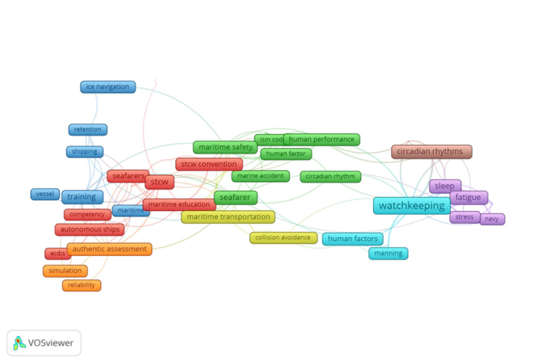

Figure 1. Network Visualization

The relationships between terms are shown in Figure 1 in the network visualization. The relationships are represented by networks or lines that connect one concept to another. Based on the results of data processing with VOSviewer based on keywords, there are 6 clusters, namely Cluster 1 consisting of 13 items, namely autonomous shipping, autonomous ship, certification, competence, competency, ecdis, maritime education, maritime education and training, mass, seafarer, safaring, STCW, STCW Conventions. Cluster 2 consists of 9 items, namely cyrcadian rhythm, human error, human factor, human performance, ISM Code, marine accident, marine accidents, maritime safety, seafarer. Cluster 3 consists of 9 items, namely education, ice navigation, marine safety, maritime, retention, shipping, simulator training, training, vessels. Cluster 4 consists of 6 items, namely collision avoidance, maritime English, maritime training, maritime transportation, risk management, safety. Cluster 5 consists of 5 items, namely fatigue, navy, sleep, sleepiness, stress. Cluster 6 consists of 4 items, namely automation, human factors, manning, watchkeeping. Cluster 7 consists of 4 items, namely authentic assessment, reliability, simulation, validity. Cluster 8 consists of 3 items, namely circadian rhythms, performance efficiency, subjective alertness. Cluster 9 consists of 2 items, namely maritime education and training, weather ship routing.

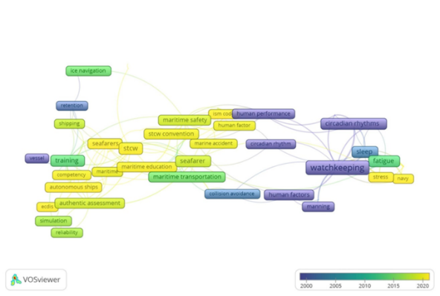

Figure 2. Overlay visualization

Research trends related to watchkeeping from year to year. Based on the picture, it can be explained that research around 2000 was about watchkeeping, manning, circadian rhythm, human performance, then in 2015 about navigation, maritime transportation, fatigue, training. Research in 2020, among others, while in 2020 discussed more about stress, navy, ISM code, human factors, marine accidents, STCW Convention, seafarers, maritime education.

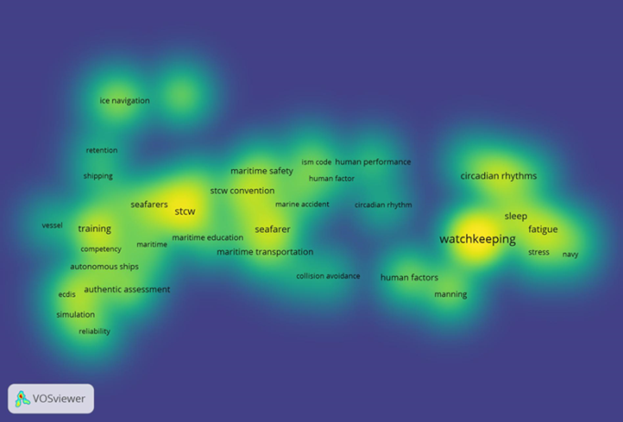

Figure 3. Density visualization

The image shows the density of research, meaning that the denser the color, the more research is being carried out. The darker the yellow color and the greater the width of the circle, the closer together the keywords are. This shows that research on this topic is becoming more general. The number of studies is decreasing until the color fades and mixes with the green background. Each group or cluster. Each relationship between groups.

Implementing a good and correct watch service on a ship is by carrying out monitoring planning, responding to emergencies, carrying out effective communication, being alert to potential problems while the ship is sailing, arranging rest times, and maintaining equipment so that it functions properly.

The implications regarding the implementation of watchkeeping on ships include various concepts and principles that must be understood by the crew in operating the ship so that they can ensure the safety of the ship's crew and their cargo. The implementation of watchkeeping duties must comply with regulations to prevent ship accidents. Ship crew carrying out watchkeeping must understand the risk of fatigue and psychological stress which can affect performance [8].

Overall, bibliometric analysis on the topic of watch keeping provides important insights into the research analyzed, which will help researchers, practitioners and policy makers understand the latest developments which are increasingly dynamic and continue to develop. This overview identifies keyword groups, authors, or documents related to the watchkeeping topic and thus provides insight into key themes and future research directions. Analysis using a bibliometric approach was used to identify keywords from each study. Apart from that, this analysis can also be used to determine novelty before conducting further research on the same topic.

# CONCLUSION

The implementation of good and correct guard duty on a ship is by carrying out monitoring planning, responding to emergencies, carrying out effective communication, being alert to potential dangers while the ship is sailing, arranging rest times, and maintaining equipment on the ship so that it functions properly. The keyword used in this bibliometric research is watchkeeping. The number of research topic keywords linked to VosViewer is limited to 2. There were 411 keywords and 59 related keywords which were divided into 6 clusters. Bibliometric analysis identifies keyword groups, authors, or documents related to the watchkeeping topic, thereby providing insight into key themes and future research directions.

# REFERENCE

[1] H. Sampson and M. Thomas, “Risk and responsibility,” *Qualitative research*, vol. 3, no. 2, pp. 165–189, 2003.

[2] A. Sharma and T. Kim, “Exploring technical and non-technical competencies of navigators for autonomous shipping,” *Maritime Policy & Management*, vol. 49, no. 6, pp. 831–849, 2022.

[3] L. Fan, J. Fei, U. Schriever, and S. Fan, “The communicative competence of Chinese seafarers and their employability in the international maritime labour market,” *Marine Policy*, vol. 83, pp. 137–145, 2017.

[4] S. Folkard, “Shift Work, Safety, and Aging,” *Chronobiology International*, vol. 25, no. 2–3, pp. 183–198, Jan. 2008, doi: 10.1080/07420520802106694.

[5] M. Lützhöft, M. R. Grech, and T. Porathe, “Information Environment, Fatigue, and Culture in the Maritime Domain,” *Reviews of Human Factors and Ergonomics*, vol. 7, no. 1, pp. 280–322, Sep. 2011, doi: 10.1177/1557234X11410391.

[6] C. Hetherington, R. Flin, and K. Mearns, “Safety in shipping: The human element,” *Journal of Safety Research*, vol. 37, no. 4, pp. 401–411, Jan. 2006, doi: 10.1016/j.jsr.2006.04.007.

[7] G. Exarchopoulos, P. Zhang, N. Pryce-Roberts, and M. Zhao, “Seafarers’ welfare: A critical review of the related legal issues under the Maritime Labour Convention 2006,” *Marine Policy*, vol. 93, pp. 62–70, 2018, doi: https://doi.org/10.1016/j.marpol.2018.04.005.

[8] A. P. Smith, P. H. Allen, and E. J. K. Wadsworth, “Seafarer fatigue: The Cardiff research programme,” 2006.

[9] I. Marando, K. Lushington, M. Owen, R. W. Matthews, and S. Banks, “The sleep, circadian, and cognitive performance consequences of watchkeeping schedules in submariners: A scoping review,” *Sleep Medicine Reviews*, vol. 72, p. 101845, Dec. 2023, doi: 10.1016/j.smrv.2023.101845.

[10] M. A. Short, A. Agostini, K. Lushington, and J. Dorrian, “A systematic review of the sleep, sleepiness, and performance implications of limited wake shift work schedules,” *Scandinavian journal of work, environment & health*, pp. 425–440, 2015.

[11] J.-H. Guo *et al.*, “Circadian misalignment on submarines and other non-24-h environments–from research to application,” *Military Medical Research*, vol. 7, pp. 1–12, 2020.

[12] N. J. van Eck and L. Waltman, “Crossref as a source of open bibliographic metadata,” 2022.

[13] A. Baneyx, “‘Publish or Perish’ as citation metrics used to analyze scientific output in the humanities: International case studies in economics, geography, social sciences, philosophy, and history,” *Archivum immunologiae et therapiae experimentalis*, vol. 56, pp. 363–371, 2008.

[14] J. Baas, M. Schotten, A. Plume, G. Côté, and R. Karimi, “Scopus as a curated, high-quality bibliometric data source for academic research in quantitative science studies,” *Quantitative science studies*, vol. 1, no. 1, pp. 377–386, 2020.

[15] W. H. Teichner, “The detection of a simple visual signal as a function of time of watch,” *Human factors*, vol. 16, no. 4, pp. 339–352, 1974.

[16] B. Barrass and C. D. Derrett, *Ship stability for masters and mates*. Elsevier, 2011.

[17] Ö. Uğurlu, “Application of Fuzzy Extended AHP methodology for selection of ideal ship for oceangoing watchkeeping officers,” *International Journal of Industrial Ergonomics*, vol. 47, pp. 132–140, 2015.

[18] J. Sánchez-Beaskoetxea, I. Basterretxea-Iribar, I. Sotés, and M. de las M. M. Machado, “Human error in marine accidents: Is the crew normally to blame?,” *Maritime Transport Research*, vol. 2, p. 100016, 2021, doi: https://doi.org/10.1016/j.martra.2021.100016.

[19] R. Phillips, “Sleep, watchkeeping and accidents: a content analysis of incident at sea reports,” *Transportation Research Part F: Traffic Psychology and Behaviour*, vol. 3, no. 4, pp. 229–240, Dec. 2000, doi: 10.1016/S1369-8478(01)00007-9.

[20] J. Rutenfranz *et al.*, “Work at sea: a study of sleep, and of circadian rhythms in physiological and psychological functions, in watchkeepers on merchant vessels: II. Sleep duration, and subjective ratings of sleep quality,” *International archives of occupational and environmental health*, vol. 60, pp. 331–339, 1988.

[21] M. Celik, I. D. Er, and Y. I. Topcu, “Computer-based systematic execution model on human resources management in maritime transportation industry: The case of master selection for embarking on board merchant ships,” *Expert Systems with Applications*, vol. 36, no. 2, pp. 1048–1060, Mar. 2009, doi: 10.1016/j.eswa.2007.11.004.

[22] S. Ghosh, M. Bowles, D. Ranmuthugala, and B. Brooks, “Reviewing seafarer assessment methods to determine the need for authentic assessment,” *Australian Journal of Maritime & Ocean Affairs*, vol. 6, no. 1, pp. 49–63, Jan. 2014, doi: 10.1080/18366503.2014.888133.

[23] Ö. Uğurlu, S. Kum, and Y. Aydoğdu, “Analysis of occupational accidents encountered by deck cadets in maritime transportation,” *Maritime Policy &Management*, no. Query date: 2023-03-25 12:09:02, 2017, doi: 10.1080/03088839.2016.1245449.

[24] W. P. Colquhoun, “Hours of work at sea: watchkeeping schedules, circadian rhythms and efficiency,” *Ergonomics*, vol. 28, no. 4, pp. 637–653, Apr. 1985, doi: 10.1080/00140138508963178.